UNIVERSITY OF CALIFORNIA, SAN DIEGO

Thinking in English:
Building Critical Literacy with Refugee English Learners

A Thesis submitted in partial satisfaction of the
requirements for the degree Master of Arts
in
Teaching and Learning
(Research in Curriculum Design)

by

Skye Marie Cooke-Pinon

Committee in charge:
Luz Chung, Chair
Cheryl Forbes
Caren Holtzman
2014

Copyright
Skye Marie Cooke-Pinon, 2014
All rights reserved.

The Thesis of Skye Marie Cooke-Pinon is approved and it is acceptable in quality and form for publication on microfilm and electronically:

__________________________________________________________

__________________________________________________________

__________________________________________________________
Chair

University of California, San Diego
2014

Dedication

This thesis is simultaneously dedicated to my family and to my students, who support and inspire me everyday to be a better mother, wife, daughter, sister, friend, and teacher.

Table of Contents
Signature Page………………..…………………………………………….……….iii
Dedication iv
Table of Contents v
List of Tables vii
List of Figures viii
Acknowledgements x
ABSTRACT OF THE THESIS xii
CHAPTER I. INTRODUCTION 1
CHAPTER II. NEEDS ASSESSMENT 4
Current Linguistic Situation 4
Current Situation in California 6
Desired Conditions 8
CHAPTER III. REVIEW OF RELEVANT LITERATURE 11
Sociocultural and Ecocultural Theories 12
Critical Literacy 16
Metacognition and ELs 22
Summary 23
CHAPTER IV. REVIEW OF EXISTING CURRICULA 25
Integrated Approaches 27
Content-Centered Approach 29
Participatory Approach 30
CHAPTER V: CRITICAL THINKING WITH NEW ARRIVAL ENGLISH LEARNERS 32
Project Overview 32
Goals of the Project 34
Curriculum Model and Features 36
Receptive Tasks 38
Expressive Tasks 39
Summary 40
CHAPTER VI: IMPLEMENTATION OF THINKING IN ENGLISH 41
Description of Setting 41
Implementation of Activities 45
Activity 1 – I Have a Dream, Too 45
Activity 2 – Photo Gallery Analysis 49
Activity 3 – A-G Pathway to Graduation 53
Activity 4 – Art Analysis 56
Activity 5 – Graphic Storytelling 59
Summary of Approach 61

CHAPTER VII: EVALUATION OF THINKING IN ENGLISH 63
Research Questions and Goals 63
Field and Anecdotal Notes 66
Receptive Task Responses 69
Expressive Task Mini-Projects 71
End of Unit Project 77
Use of Rubrics 79
Findings 81
Goal #1 81
Finding 1: 81
Goal #2: 87
Finding 2: 87
Finding 3: 89
Goal #3 91
Finding 4: 92
Finding 5: 96
Discussion 99
CHAPTER VIII: CONCLUSION 102
APPENDIX 105
Sociocultural and Ecocultural Theory 111
Critical Literacy 111
Unifying Theme of Goals 113
References 136

List of Tables

Table 1. Goals and curricular activities that support each goal. 36

Table 2. Goals and data collection strategies. 66

Table 3. Rubric created that was used to measure critical thought on receptive tasks. Also available in the Appendix. 80

Table 4. Rubric I created for the Art Response expressive activity, showing increasing levels of clarity of representing their goals through the art piece students created. Also available in the Appendix. 80

Table 5. ADEPT scores for January 2014 and June 2014 83

Table 6. Running Record Scores from January 2014 and June 2014 demonstrating improved reading levels in all students. 86

Table 7. Levels of critical thought displayed in responses to assess developing critical literacy. 90

List of Figures

Figure 1. Diagram of Bronfenbrenner's model of ecological systems 13

Figure 2. Initial countries/cultures of origin of class, January 2014. 43

Figure 3. Final countries/cultures of origin of class, June 2014 44

Figure 4. Student example of "I Have a Dream, too" speech. 47

Figure 5. Student sample of photo gallery activity 51

Figure 6. Student example of pre-activity graduation plan. 54

Figure 7. Student example of post-activity graduation plan 55

Figure 8. Example of student response sheet for art analysis 57

Figure 9. Example of student planning sheet and art 58

Figure 10. Picture of student's story describing their future goals 61

Figure 12. Student example of receptive task response sheet for photo gallery response sheet 70

Figure 13. Example of student's "I Have a Dream, too" speech 72

Figure 14. Student photograph of goal. 73

Figure 15. Student explanation sheet of the goal she photographed 73

Figure 16. Student explanation of the goal chosen from Google 74

Figure 17. Student's incomplete pre-activity planning sheet. 75

Figure 18. Student completed post-activity planning sheet 76

Figure 19. Two-page example of a student's story about her goals 78

Figure 20. Student rubric scores for oral presentations 84

Figure 21. Student rubric scores of critical literacy 91

Figure 22. Indicators of student understanding of the US system of education. 93

Figure 23. Number of changes in the pre and post activity planners 95

Figure 24. Comparison in number of students seeking or offering assistance and working independently. 98

Acknowledgements

When I finished my teaching credential a number of years ago, I thought then that I might not ever go back for a Master’s degree. I knew that my heart would always be in classroom teaching, and I knew that I didn’t need a Master’s degree to continue to do so, so the thought of going back to school seemed far off. I went on to get married and have four amazing children, and over the years would occasionally think about going back to school to get my degree but would always rationalize all of the reasons why I couldn’t or shouldn’t. I eventually came to a position in both my personal and professional life that led me to realize that now is the time for me to take this step and pursue my Master’s degree. I know that none of this work could have been possible without the incredible inspiration I have gotten from my amazing students. I want to thank you all for showing me what a true commitment to learning looks like and for reminding me what that dedication looks like in pursuit of a quality education.
I probably wouldn’t have applied to the MA program at UCSD at all with out the encouragement of my friend and colleague, Kristy Drake, who continually inspires me with her own professionalism and dedication to the craft of teaching and professional growth. She is also a busy wife, mother, and teacher, and charged ahead in her own search of professional growth in the UCSD program all the while reporting back to me so I would know what to expect as I followed in her path. I know I would not have had the guts or the confidence to apply to, and complete the Teaching and Learning MA program at UCSD without her support and encouragement, along side a heavy dose of brutal honesty about what it’s like to be a MA student while also balancing family and a career.
I also know I owe infinite gratitude to the EDS faculty for a program that so perfectly guides groups of insecure teachers to becoming confident researchers and curriculum writers in our own craft. I don’t know how I could have possibly completed any level of work on my thesis without the support of Cheryl Forbes, Paula Levin, and Luz Chung throughout this course of my own development. That advice we got as an incoming cohort to “trust the process” could not have been more accurate, and I will be eternally grateful to those that designed and continue to implement this program.
Finally, I thank my husband, my children, and my mother for their incredible support and for allowing me to spend more hours than I can count at the nearest Starbucks reading, writing, revising, and sometimes just staring at my computer and trying to process my thoughts. I thank you for giving me all the time I needed and for never making me feel guilty for taking this time to better myself as a teacher, and as a human being. Your love and encouragement helped me get through the toughest times when I didn’t think I could do it, and I truly feel like we all share this degree.

ABSTRACT OF THE THESIS

Thinking in English: Building Critical Literacy with Refugee English Learners

By

Skye Marie Cooke-Pinon

Master of Arts in Teaching and Learning (Research in Curriculum Design)
University of California, San Diego, 2014
Luz Chung, Chair

There is a very unique population of students who are not often represented in research and literature. These are beginning English learners, secondary students who are recent immigrants from areas with limited or interrupted formal education. These students are often from areas of great conflict and many of them have had traumatic experiences before being resettled in the United States. Many of these students arrive in the US with a strong desire to better their circumstances through education.
The Thinking in English curriculum addresses the notion that when refugee English learners are challenged to use critical literacy in a series of activities that include a common theme of goals, their language proficiency will improve, as well as their critical thinking and decision-making in relation to their understanding of the educational system of the United States. It was implemented in a large, urban district in southern California where students were enrolled from a variety of countries around the world and spoke a variety of languages and dialects. Over a series of activities, the students were challenged to think critically through receptive and expressive tasks that built on a topic of setting goals and provided them appropriate scaffolding to meet their language needs. The data shows that students with limited prior education with very beginning English proficiency can successfully improve their proficiency while also building critical literacy that will help them become more successful as members of the social and educational community of the United States.

CHAPTER I. INTRODUCTION

For the first seven years of my professional life, I taught in mainstream education first at an elementary school, then at a secondary campus. I had many students with a variety of educational styles and needs, but there was also a familiarity I felt with the established curriculum and camaraderie with all of the staff who shared my students or my content area. I also found allies in the conversations I had with parents about their child’s course of study as we shared strategies and frustrations together and I felt comfort in the district, state, and nationwide discourse about the work that I was doing as teacher.
Even after moving from mainstream teaching into a position teaching English as a second language, or ESL, at a middle school I continued to enjoy most of these familiarities. This was my first position as an ESL teacher and I was pleased to realize that despite the language barrier, it was relatively easy to find a translator if I needed to communicate with the students or their families. In addition, teaching students to speak, read, and write better in English is a very common topic of study and professional development, so I always felt I was learning new and proven teaching strategies and techniques.
Upon moving to San Diego from the Central Coast of California, I sought out ESL teaching positions partly because of my background and experience in the field. When I began a position in the New Arrival Center of a large urban district in southern California, I was thoroughly surprised at how different the work was from the teaching position I held further north. I was instantly taken aback by the incredible diversity of the neighborhood I was teaching in. In my classroom alone, close to ten different languages were spoken by my students versus just the Spanish that was spoken in my previous class, which obviously made communication with parents and students much more difficult. In addition, I now had students in my class who had never, or rarely, been to school prior to arriving in the United States, while my previous experience had been with students who had attended school continuously. I realized quickly that I had to teach them the “culture of school” and how to build stamina as a thinker, in addition to teaching them English. There was also a lack of very basic ESL curriculum, especially a this secondary level, that was developmentally appropriate for work with high school students, and I constantly found myself on a “scavenger hunt” for materials and resources that I felt would work for my students’ needs.
There were also many additional issues to the new program that I was working in that went beyond the classroom itself. Many of my students were refugees and had survived in some of the most difficult and dangerous situations imaginable, and therefore had some lingering emotional and physical trauma that affected their learning. In wanting to find out more information about how to help these students, I realized that there is a lack of accessible research that explicitly states how to best meet the needs of this unique population of students in this new environment. There were books about refugees, and there were books about teaching ESL students, but there wasn’t much in the way of teaching refugee students to read, write, speak, and think in English.
Because of this experience in working with these students of such incredible circumstances, I felt a desire to further develop and grow professionally in an attempt to provide my students with a more deliberately proactive educational experience that addresses their unique needs. Since these students needed both beginning English language and critical literacy support tailored to specific aspects of succeeding in the US system of education, I felt it was my opportunity to learn how to best provide that to them. It was from here that I began to research and develop the Thinking in English curriculum as a means for incorporating a level of beginning English instruction along with specific skills in critical literacy to help my students find greater success in the United States.

CHAPTER II. NEEDS ASSESSMENT

Current Linguistic Situation
In the United Stated, rates of immigration are continuing a rising trend and as the numbers of immigrants grows, so do the numbers of students enrolling in US schools with limited English. Because of those numbers, schools are also finding increasing numbers of students enrolling with limited or interrupted formal education (Decapua, 2005). These students may be from refugee camps, conflict zones, or other areas where the quality of education is inconsistent at best and therefore, schools and teachers are being faced with a constantly changing demographic of students with both limited English ability and often interrupted or nonexistent prior education. Schools must find ways to adequately provide a quality education that prepares these students to successfully integrate themselves into the educational system and job markets of US society. Given this situation, the challenge is to teach these students, both to speak English at a level where they can successfully complete their course of education and to learn to critically think about and navigate the system of higher education and career fields in order to maximize the opportunities they may have. Teaching these students to become more proactive and critical consumers of education will have the extended benefit of creating a network of informed members of social and cultural groups that can become advocates for change in the current societal structure.
In further investigation of this problem, the situation becomes critical when the implications are considered of not providing these adolescent EL students with interrupted formal education with adequate acceleration of their academic English and critical literacy skills. Garcia (2009) describes the cognitive advantages of bilingualism and the notion of metalinguistic awareness in using language as a production of thought so by extension, not giving English learners adequate instruction in English to further their ability to become bilingual in their native language along with English, they are being effectively limited in their ability to construct abstract thought. In acquiring these critical skills of both language and metacognition, students will become more competent bilinguals in a multilingual world. Additionally, as they gain proficiency in English, students will develop a greater understanding of their own position and progress within the context of the US system of education and will be able to effectively evaluate both the content and the path of their education, and make decisions accordingly that will ultimately lead them to more successful and appropriate opportunities for education and employment.
Due to the predominance of literature on language learner students that focuses on Spanish-speaking students learning English (Garcia, 2009), there is a limited amount of research in areas where a multitude of language groups are represented. Kleyn & Reyes (2011) describe the fact that there are many difficulties in creating effective bilingual programs that address the needs for communities with a wide variety of languages and cultural groups as opposed to areas where the students are from monolinguistic background other than English. In classrooms that are linguistically and culturally diverse, implementation of effective culturally additive approaches to learning as a means to support the education of diverse learners becomes more complex, and therefore more challenging to successfully implement (McBrien, 2005).

Current Situation in California
A growing number of districts in California are requiring students to successfully complete a required course of study known as the A-G Requirements that delineates a series of seven content areas (each area being labeled with letters from A-G) and a number of years of study in each. Many other states are requiring a higher level of credits earned because of No Child Left Behind (NCLB) legislation, so there is a great sense of urgency in recent years in getting all students up to grade level coursework. Students with limited English especially struggle with academic content areas, such as science and history, due to the increased language and vocabulary demands and often-limited schema, or background knowledge about specific topics (Miller, 2009).
In an effort to further a college-going culture, some districts in California have also adopted the rigorous course requirements that California public universities use to determine eligibility as a high school graduation requirement for all of its students. With this adoption, all students must take and pass a series of classes that fall into subject-area categories along a particular course of study in order to be eligible for high school graduation (CA Department of Education, 2014). In this requirement, students are assumed to have access to all of the required courses, including opportunities to repeat or remediate when necessary, within the four years typical of a high school experience. However, with regard to English learners, this potentially becomes problematic in that the first two years of English as a second language coursework do not count as being grade-level material and are thus do not satisfy the A-G requirement. Ultimately, these new requirements put English learners at a distinct disadvantage for graduating within a four-year timeframe typical of non-English learners.
Additionally, all high school students in California must take and pass the rigorous California High School Exit Exam in order to receive a diploma, a test which is particularly difficult for students with diverse linguistic and cultural backgrounds, and often ends up as an insurmountable obstacle for many ESL students (Wells, Gambero, Allen, Juarez, 2012). Across the nation, other states have implemented similar exams, such as New York’s Regents Exam or Texas’s Texas Assessment of Knowledge and Skills (TAKS), that require students to meet a standardized set of criteria before being given a diploma, with mixed impact on student achievement (Jacob, 2001). While data from such high stakes testing in some states have shown increases in student graduation rates, there has also been growth noted in unintended consequences for English learners, such as student dropout rates due to increased anxiety and alienation following a failing attempt by low performing students (Richman, Brown, Clark, 1987, Heilig, 2011).
This group of students with both limited English and interrupted formal education represents a great proportion of the national percentage of high school dropouts (Short & Boyson, 2000, Decapua & Marshall, 2010). Because of their lack of opportunity through more traditional educational channels, they tend to disproportionately make up the percent of students who fall into patterns of crime, drug and alcohol abuse, gang activity, sexual promiscuity, etc., and therefore often have trouble with the law (Rumberger & Gandara, 2004, McBrien, 2005). When individuals with language barriers become involved with those in positions of authority or the legal system, there is the potential for communication issues that may be problematic and add to the severity of the infraction (Sanger, Moore-Brown, Magnusen, Svoboda, 2001). Whether these issues stem from a lack of opportunity through educational pathways, or from a general lack of English or understanding of the laws and justice system of the United States, failure to educate these immigrant youth is having a detrimental effect on those individuals, their communities, and our greater society. Garcia (2009) contends that language construction is connected to political power or control, and that languages are socially constructed, so therefore, by limiting a student’s ability to participate in the majority language of a particular group, whether purposeful or by educational negligence, that student is effectively marginalized from full and meaningful participation in that society.

Desired Conditions
Once refugee students and their families are relocated to the United States, or elsewhere, they must find ways to adjust to their new, and totally different, environment. While adjusting, they must also continue to learn to deal with the past stresses and incredibly difficult lives they were forced to lead and eventually move on to live a productive life here (McBrien, 2005). While learning the language of the land, they are also expected to follow the laws, participate in the educational system, eventually become self-sufficient and provide financial support for themselves, and somehow, also plan for their future.
It becomes imperative, then, that we create a program that best addresses a variety of needs for this population of students given the fact that at the secondary level, students have a limited time in school before they are expected to graduate and move into post-secondary or adult education. There must be a cohesive and seamless blending of English language development and academic and critical literacy, in addition to an environment of respect for cultural and linguistic diversity, an available network of additional resources to address factors such as financial, emotional/psychological, social, medical, and educational needs. In order for a program to be most successful, there must be a level of cultural awareness and sensitivity on the part of the staff as well as an approach to education that respects and maximizes a cultural group’s history and values (Watkins, 2012). In doing so, educators can work within a particular group’s communication and learning style in a way that will be culturally sensitive and not off-putting or disrespectful.
This is particularly poignant in adolescents who are still developing and maturing. As these youth become part of a new society, they may have difficulty in developing their own cultural identities while also adjusting to a new society, a new school system, and often times, a new language. Adolescent refugees must overcome this shift in the context of their development while also dealing with traumatic experiences such as war and death (Luster, Qin, Bates, Rana, and Lee, 2010).
In my own teaching experience working with recently arrived refugee high school students who Garcia (2009) would label as emergent bilinguals, there is a huge network of experiences, some positive and some highly traumatic, that each student has given their context for development in their first country. Upon moving to the United States, they must learn to adjust and social, communicatively, and cognitively function within this new environment that is so drastically different from that which they previously knew. As educators in an increasingly changing and globalized society, research in areas of adolescent refugee resettlement and education are more pertinent than ever.
According to the Dakar Education for All framework (Biraimah, 2005), which addressed the educational needs of diverse students around the world in an international coalition, we must expand the scope of education to include a more integrated approach that considers cultural identities and looks beyond merely traditional methods of teaching. In this framework, countries from around the world participated in this commitment to providing the right to an education that is designed to access its citizen’s collective and individual talents in an effort to maximize the potential within their own societies. Here in the United States, this goal can be addressed with refugee students through the implementation of key instructional practices such as small-group reading instruction, collaborative work, scaffolding, and differentiation in supportive classroom environments (Decapua & Marshall, 2009). However, traditional secondary classrooms are frequently based on European models of direct instruction and decontextualized learning that typically don’t address the needs of English learners with interrupted formal education who often enter the US school system with varied life experiences and a lack of academic background McBrien, 2005).

CHAPTER III. REVIEW OF RELEVANT LITERATURE

It is clear that around the world, rates of immigration are continuing a rising trend, including the relocation of millions of refugees and internally displaced persons (Guerrero and Tinkler, 2010). As more and more refugees are being displaced from their homes in countries and areas of conflict, the numbers of these refugees resettling in western cultures is continuing to rise. Because of those numbers, societies are also finding increasing amounts of people who may be from refugee camps, conflict zones, or other areas where the quality of life is inconsistent at best and therefore, are being faced with a constantly changing demographic makeup that includes a large population of students who may struggle to acculturate and learn. Once these students and their families are relocated, they must find ways to adjust to their new, and totally different, environment. While adjusting, they must also continue to learn to deal with the past stresses and incredibly difficult lives they were forced to lead and eventually move on to live a productive life in their new land.
To this end, there are a number of relevant theories and frameworks that may be used to consider ways to promote cognitive and linguistic development in a culturally sensitive and effective manner. It was through these constructs, that the Thinking in English curriculum was developed in an effort to promote progress in English language proficiency and critical thinking skills in these new arrival students.

Sociocultural and Ecocultural Theories
The notion of culture and development as being intertwined can be imagined in a variety of ways. In sociocultural theory, learners develop through their interactions with others while in ecocultural theory, the surrounding influences, including other people, are a context for learning. Using ecology as a perspective for studying human development is a particularly interesting and complex way to look at the phenomena of language acquisition and refugee acculturation. In his work on ecocultural theory, Bronfenbrenner (1986) describes the ways in which external factors influence development. The radiating levels of the individual microsystems, mesosystems, exosystems and macrosystems easily apply to the ways that their old and new environments influence individuals undergoing a cross-cultural transition. In the setting of this project, the individual student would be considered the microsystem with the influences (such as peers, family, and local community) on that individual being the mesosystem. Larger, systematic forces like the parents’ workplace, local laws and services, and societal customs are the exosystem and the overarching settings that have an indirect influence on the environment of the child (i.e. learning a language, government policies about immigration, etc.) (Bronfenbrenner, 1986).
Through the interaction with differing levels of influence such as the individual and the family, the local community, and broader social contexts of political and educational institutions, the individual develops a unique ecocultual perspective that is comprised of all of these forces that impinge on everyday activities (Weisner, 2002). As these circumstances change, quite dramatically in the case of relocated refugees, the ecocultural model shifts the trajectory of the path of cultural human development along a chronosystem, or the timing of life events like the birth of a sibling or age at the time of immigration, of interaction as that individual continues to develop (see Figure 1).
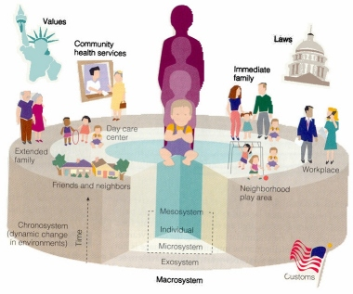
Figure 1. Diagram of Bronfenbrenner's model of ecological systems
EDFD127 Group 20 Wikispaces, http://edfd127.wikispaces.com/Bronfenbrenners+Ecological+Systems+Theory

Furthermore, according to Hou and Beiser (2006), learning the language of the receiving society has a marked impact on acculturation, and on overall mental health, in newly arrived immigrants. As such, language learning also becomes a key factor in the social and cultural contexts in which an individual is able to continue their development and integration to the new society. When considering the interactions an individual has with their environment, language proficiency must also be examined for the ways it will impact the quality of interactions individuals have within a newly established context for development. For example, if an immigrant is relocated to a society with a similar structure and a familiar language, their acculturation will be facilitated by that individual’s ability to negotiate the overt and hidden curriculum of that society. By contrast, however, if an individual is hindered by their inability to communicate in the dominant language of their new society, there will be an increased likelihood of misunderstandings and cross-cultural frustration. Using the ecocultural systems model, language could be seen as a lens with varying degrees of clarity over which interactions between an individual and their surrounding environments of their educational systems could be viewed.
By applying sociocultural theory to the education system, all students exist as both individuals and as part of a greater societal whole. Thus, there is a connection between cognitive development and social development (Walqui, 2006) that must be considered when designing instruction. Students should be encouraged to interact as a way to formulate a position within the context of their relationship with others and as a way to grow in their own intellectual development. According to Blau (2003), all readers have a role in society that affects the way they see the world and therefore how they take meaning from text, so when working with students, we must remain cognizant of that as we design instruction.
For example, in a study of the expert-novice interaction of two students in an EL classroom, Adair-Hauck and Donato (1996) describe the transformation of the L2 beginner as moving from a passive stance where the onus for learning is primarily with the expert to one where the novice is able to take almost complete ownership. What is interesting to note, however, is that there is no requirement for absolute authority for learning to be present because when individuals bring their own experiences to a collaborative environment, each is able to co-construct meaning in a way that enables them to be both the contributors and recipients of the learning (Lantolf and Pavlenko, 1995).
This notion of a cooperative learning environment aligns with Vygotsky’s idea of the Zone of Proximal Development (ZPD) in that there is a dialectical relationship among the parties in learning that allows for various individuals to be able to bring forth unique contributions that collectively enhance the learning that takes place (Hung and Chen, 2001). This relationship should be an active and evolving one that is based on both the environment and the goals of those involved. In the notion of the ZPD, adults or peer experts maximize a child’s potential when the child moves from the learning that takes place through independent problem solving to the increased level of development when that child is mentored.
When teachers and student peers co-construct meaning in their classrooms, the environment for learning is affected and made more collaborative. With ecocultural theory guiding this line of thinking, this creates a type of cooperative setting between students, their peers, their teacher, or even the activities themselves that ultimately affects a student’s motivation and achievement (McInerney & Etton, 2000). Furthermore, a student’s perspective on themselves as a reader is instrumental in helping students orient themselves in a position where they see themselves as being competent contributors to learning rather than just recipients of it.

Critical Literacy
The movement of educational scholars from the previously dominant thought that literacy is gained and developed by gleaning meaning from text to a new line of thinking that there are cultural and social factors that influence literacy is termed New Literacy Studies, or NLS (Street, 2005). In this newer field of study, emphasis is no longer solely on the acquisition of literacy through reading, but instead incorporates the manner in which social and cultural contexts affect literacy and meaning.
Through this newer approach, cultural context has an accepted influence on learning, and specifically on literacy. By taking a more inclusive approach when developing literacy we can further our understanding of how to best incorporate strategies that will holistically address the educational needs of our students. These ideas about using the social and cultural contexts of our students should become formative guiding principles as educators work to develop curriculum, assessment, and teacher training programs in order to best meet the educational needs of a diverse population of students.
By applying the strategies of sociocultural theory and those of critical literacy when designing curriculum for teaching and learning, a student’s unique background becomes a potential source of strength in a cooperative learning environment. It is also here, in this phase of application however, where these ideas will be vetted for their relevance and practicality and true validity will be established, as opposed to ideas about education that have only a theoretical foundation with a lack of actual implementation in real world settings (Street, 1997). Unfortunately, however, there is a noted lack of empirical research on instructional best practices for English learner students (Goldenberg, 2013), particularly at the secondary school level, and further study should be conducted.
This notion of “new literacy studies” is not really “new”. Scholars have debated the social implications on literacy for quite some time. From the time when literacy was seen as a social privilege or as a means to political organization to more recent social expectations for all individuals to possess some level of literacy, it has had an impact of society whether stated or implied (Freire & Macedo, 1987). If we fail to address the social context when we teach, we are keeping students in a passive role of being the continual receivers of education, rather than having an active, participatory stance that enables them to feel more engaged and proactive (Freire, 2000).
Teaching students to use more critical thinking in their own learning and making the social context a more explicit part of their literacy aligns with the notion of culturally responsive education which argues that teachers should make connections with their students in order to better understand the sociocultural context that affects their learning (Klinger & Edwards, 2006). If we are to provide a more effective education for all students, we must address the unique learning styles and sociocultural backgrounds that are a part of their literacy.
Educational institutions and teachers can begin by helping these students create a new identity that enables them to incorporate their experiences and possible past traumas rather than to find these elements of their lives as simple obstacles to overcome. Hones (2007) describes a critical pedagogy that includes social, cultural, and academic support as a means to engaging these refugee English learner students more deeply in their own education in a way that helps them learn new academic content and language while also learning a new culture. Additionally, research shows that teaching critical literacy skills such as text analysis alongside beginning literacy skills is not only possible, it is often beneficial (Dooley, 2009), even at the advanced age typical of high school students.
According to Park (2012), critical literacy can, and should, include meaningful interactions with text as well as reading both the word and the world where students not only read to understand the world around them, but they use their understanding of that world to help them make better critical decisions about it (Freire, 1987). In incorporating critical literacy strategies in teaching, we can make reading and learning more pertinent, valuable, and enduring for our students (Park, 2012). Dooley (2009) describes how using a critical pedagogy in the classroom can help teachers validate and expand students’ perspectives while honoring their linguistic and cultural abilities and encouraging their ongoing academic development.
One strategy for moving from reading instruction to critical literacy is the notion of visualizing (Park, 2012). In her study of seventh and eighth grade girls at an urban middle school, Park (2012) created an afterschool book club in which these students voluntarily participated in readings and discussions where they were prompted to think critically and visualize various elements of literary texts. With visualizing, students can begin to see the story through their own worldviews and identities, which facilitates richer literary thought and conversations. Though Park’s (2012) study focused on English-proficient students, it has been found that encouraging the use of visual representations that go beyond just written or oral explanations helps extend understanding and provide additional support for learning in students of non-native English backgrounds (Goldenberg, 2013).
Additionally, Elbow (1995) describes how this ability to see “movies of the mind” allows students to make connections to text in a more concrete and explicit way. They learn to process more difficult issues through this increased awareness of how they fit in to the world, in addition to the connection to the text itself, and are better able to make critical decisions about what their role would or should be in various situations.
Ultimately, visualizing involves two layers: conceptualizing literary characters in text and conceptualizing oneself (Park, 2012) and each brings the reader in to a more interactive role with the literary work. When students learn to imagine characters, they often go from the concrete physical image to a more abstract vision of the quality of each character. In visualizing themselves, students may begin to reveal their subconscious beliefs about their own identities and they way they fit in to the context of the story and society at large.
In addition to visualizing as a way to foster critical literacy, students also benefit greatly from participation in oral discussions as a way to develop both social and critical reading strategies (Park, 2012). In the field of literacy, communication and discourse strategies have been compared to building blocks for meaning (Au, 1998) so it seems obvious, then, that students should be given opportunities to engage in rich conversation. When dialogue and social interaction become the basis for learning, authentic growth and literary development occurs. This social constructivism line of thinking has some origins in Vygotsky’s early life and activities involving play and performance as critical elements of learning and development (Lake, 2012).
Through discussion and communication, students have the opportunity to discover more about the topic of discussion, and about their own identities (Park, 2012). Students can use oral communication as a means for further investigation into a topic, and in doing so, they will deepen their understanding about how they fit in to the context being discussed. In addition, in a study of native Spanish speaking students engaged in interactions with their native English-speaking teacher researchers found that these discussions can collectively contribute and add to the overall understanding and comprehension (Iddings, Risko, Rampulla, 2009).
Although reading and writing are intertwined with the elements of listening and speaking, it is important for teachers to devote time specifically for building oral language fluency. Whether it is from pronunciation, presentation, or group discussion, all students from various backgrounds must build oral language proficiency as a pathway to an overall language proficiency (Hadaway, Vardell, Young, 2001).
In conjunction with giving students the critical literacy strategies of visualization and oral discourse that will help them to be successful in learning English, teachers need to also give students the necessary tools for them to feel confident in their ability to learn. Teachers can do this by providing students with opportunities to choose activities that they find both interesting and challenging. By doing so, students will be able to develop their own sense of autonomy and competence, thus increasing their intrinsic motivation to continue learning (Deci & Ryan, 1995).
Another factor in motivation with English learners is the notion of group dynamics and learning. Since a great deal of language acquisition in learning environments is structured around building a communicative competence through classroom interaction (Clement, Dornyei, Noels, 1994), the dynamics of group cohesion are a great factor in the success of the group performance. Furthermore, this collective success is closely related to lower anxiety and higher self-confidence that ultimately benefit the individual learning a new language.
Affective factors such as attitude, anxiety, and motivation are considered a great predictor of success in language acquisition (Noels, Pelletier, Clement, Vallerand, 2000), and therefore make it worthy of consideration when designing curriculum for language development. Teachers must create classroom environments that enhance the development of the learners’ intrinsic motivation to stimulate interest in the learning of the second language, which will then contribute to the success of that learning (Wu, 2003). Ideally, this becomes a self-perpetuating cycle where students are interested in learning because they feel more successful, which helps further their interest in learning more and maximizing their potential for language proficiency and overall academic success.

Metacognition and ELs
Although extremely valuable in developing overall critical literacy, both visualization and oral discourse skills would be nearly useless if students are unable to self-monitor their thinking through metacognitive strategies. When students think about their own thinking and learning, they are automatically engaged in the process of learning. Students should monitor and self-check their progress and understanding, and can only do so when they are aware of their work. They should make conscious decisions about their learning and progress through a joint process of monitoring and self-regulatory activities (Baker & Brown, 1984). Knowing about cognition and making adjustments in regard to cognition are ways to increase overall literacy, and by not teaching our students these basic concepts in metacognition, we are indirectly handicapping them from their full potential.
Teaching students metacognitive strategies is especially critical when working with students who have limited literacy in their primary language. When students are working to acquire a second language, they often rely on their first language literacy and work to transfer that knowledge into the second language through metacognitive strategies (Genesee, Lindholm-Leary, Saunders, Christian, 2005). However, if a student is limited in their primary language due to factors such as lack of formal academic or literacy schooling, they must be explicitly taught these metacognitive skills due to their lack of intuitive transfer. English language learners must be instructed on both the strategies themselves and on how to actively and deliberately select strategies that will aid in their comprehension and task performance (Carrier, 2003).
Additionally, it is important to note the ways that students should use metacognitive skills as listeners in addition to when they read. Since oral language development is often a precursor to learning to read and write (Hadaway, Vardell, Young, 2001), the mastery of listening as a strategic skill is an important place to focus. When learning a second language, listening is critical and should be a central part of the process of language development (Long, 1985). Furthermore, studies show that when possible, developing stronger literacy skills in a students’ first language will ultimately help them strengthen those skills in their second language and includes components of phonemic awareness, oral language practice, vocabulary, written practice, and comprehension (Shanahan, 2008).
Many students are unaware of the strategies they need in order to become better learners, and yet they do want to know ways to increase their own language development (Goh, 1997) so we must instruct them on the tools and strategies to do so but hopefully in a way that enables them to become more autonomous in the process. By teaching these refugee English learners metacognitive strategies, teachers will be able to help them increase the way in which these students are able to approach challenging literacy tasks and become more mentally active in the way in which they monitor their own learning and make adjustments when needed (Goldenberg, 2013).

Summary
There are a variety of factors to consider when focusing on the needs of the unique population of refugee English learners, and teachers, administrators, and communities need to be aware of the complexities involved in developing an effective and comprehensive program (Hones, 2007). Although not easy to do, a comprehensive program can be developed that best supports refugee English learners in meaningful and productive academic development (Goldberg, 2013). By using a combined focus on social and cultural factors, along with the critical literacy components that include visualization and oral discourse, programs for English learners can be given a more solid foundation that enables them to better serve these students of such diverse cultural and linguistic backgrounds.

CHAPTER IV. REVIEW OF EXISTING CURRICULA

Newcomer programs, as specially created programs for newly arrived students, are surprisingly new in education, despite the fact that there have been continuous historic waves of immigration over time (Decapua & Marshall, 2010). Although the specific patterns of immigration may have changed over time, there has been a history of people from all around the world coming to a new country in search of opportunity. Because of this, schools in areas with high populations of recent immigrants have always been in a position of needing to find ways to address the needs of the children who are a part of this pattern. As newly arrived students, the assimilation and educational process can be intimidating and difficult, but when those students don’t speak the language, there is an additional layer of complication and need.
In the United States, there is a growing variety of newcomer programs that attempt to meet the needs of their English learners, however, these programs are relatively recent in development and often lack a long-term history of data to analyze for effectiveness. Typically, these programs are located in areas with high immigrant populations and are often in urban settings, but can be found in much smaller, rural settings if there is a need. The programs range from entirely separate facilities devoted purely to these newcomer English learners to more integrated approaches that pull these students from their mainstream courses to provide additional support in English language development, depending on the available resources and program’s philosophy and goals (Short & Boyson, 2000). Regardless of the program design, they all have a common goal of developing their students’ English proficiency and helping accelerate their successful assimilation into the educational system of the US.
Though there are great differences in the structure of these programs and they range from programs for newcomers hosted onsite at traditional high schools to high schools completely designed and run entirely for newcomers, developing curriculum to address the varied needs of newly arrived English learners is a primary goal of each program. Most newcomer programs are designed for middle and high school levels due to the incredible disparity between the English learner and the expected grade-level proficiency at that age. Materials and curricula may be readily available for teaching beginning English literacy, however much of those are created for younger students and may not be developmentally appropriate or engaging to students at the middle or high school age levels (Genessee, 1999).
The unique and specific needs of older English learners are often overlooked in curriculum design when compared to the needs of their younger peers (Gandara, Rumberger, Maxwell-Jolly, & Callahan, 2003) in a timeframe that allows them a shorter period to develop their language proficiency in English due to the logistics such as the typical four-year schedule or a common four or six-period day typical of a 9-12 educational system. Consequently, many teachers in newcomer programs laboriously design and create their own teaching materials and assessment tools in an effort to provide their students with the most useful and appropriate curriculum. However, while their efforts are genuine and valiant, they often tend to be focused primarily on the academic and literacy needs of their students but may not address the higher-level cognitive and linguistic skills that older students possess and are able to draw from when learning English (Harper & de Jong, 2004). As Hones (2007) describes, there is a great difficulty with immigrant English learners learning academic content while also learning a new culture and language, and more holistic approach that addresses the authentic life experiences of these students shows great promise in bringing together aspects of metacognition, visualizing, and discourse in developing critical pedagogy.
Regardless of their prior level of literacy in their home language, these more mature students are able to draw from a much more sophisticated background of experiences and language than elementary-aged English learners. Thus by redefining and developing curriculum that takes advantage of these strengths will further support and enhance the learning of these older students.

Integrated Approaches
Several programs have found that integrated approaches to designing their ESL curricula are warranted. These may include blending English with content areas or using a combination of interpersonal language and academic language to support each other while learning English (Crandall, 1993). Using content (i.e. Science, History, Math, etc.) as a means to foster English language development helps by giving language acquisition a specific goal or an authentic message in context that goes beyond learning language just for the sake of learning it (Krashen, 1982). Recently, the Cognitive Academic Language Learning Approach (CALLA) has been used to support students who are English learners ready to participate in content-area instruction. It is designed for students who are at intermediate and advanced levels as a way to support their transition to mainstream content classes by teaching them to use strategies to assist comprehension and retention in both content concepts and language skills (Chamot and O’Malley, 1987).
Although many programs seem to adopt the theory of using content instruction to further language development in philosophy, it is difficult to find ways that schools are able to follow that line of thought into practice based on state standards, district-wide curriculum adoptions, and lack of financial resources or time to design and implement a more integrated curriculum. Additionally, many content textbooks are based on recall and basic comprehension skills and do little to promote and develop critical literacy (Blanton, 1992) making it hard for teachers to take time out of their yearlong scope and sequence to incorporate these activities. However, It is these types of sheltered content courses tailored to meet the specific needs of these refugee English learners that, when integrated with appropriate scaffolding and differentiation, small-group instruction and theme-based learning that are the most successful content instruction programs for English learners (Decapua & Marshall, 2010).
There is also some difficulty in finding defined methods and strategies for incorporating both interpersonal language and academic language in an English language development course. While research has shown that social language is acquired more quickly than academic language (Collier, 1987), teachers often wonder how to effectively work with students at a level of proficiency that will allow them to learn content that is presented at a level far above their academic language level. Crandall (1993) describes how during the time period between a student’s development of social language and academic language students can be best served by teachers who modify the language of the texts and the tasks to meet the students at an appropriate language level and make the content accessible to all.
Crandall (1993) describes how some programs integrate content and language instruction through a language teacher or through a content teacher, or a combination of the two. Often, a language teacher will use content texts as a vehicle to teach academic language in content areas using strategies for increasing comprehension and scaffolding instruction. However, other times a content teacher will use their own texts to teach the content with a heavy and conscious focus on teaching specific language structures and English language development strategies to make their content more accessible to students with limited English proficiency. A third model for this integrated approach describes how teachers may work in teams or pairs to develop or adapt curriculum to meet the needs of English learners while still improving their overall English proficiency. However, through these integrated approaches, the content is often the item given less focus in the lesson design.

Content-Centered Approach
One way teachers can focus on content is to use content texts to teach language structures. They can do this by analyzing the structures of text an identifying certain strategies that would assist students in comprehension. Through graphic organizers, timelines, and strategic lessons based on targeted skills, teachers can provide instruction that helps students build academic literacy while also providing access to content (Janzen, 2008).
Teachers focused on content develop subject-specific goals for their students while also negotiating their understanding of how to teach English in their efforts to make instructional decisions (Howey & Grossman, 1989). Their perspective when designing lessons is continually centered on the subject matter and their lesson objectives are focused on that subject rather than the language.
Working with English learners, content learning can pose a difficulty if the language instruction isn’t given equal effort because, depending on their level of English language proficiency, the students may be excluded from the content learning altogether. Despite these challenges, Hones (2007) describes how content-based approaches can actually benefit English learners through the use of theme-based content lessons that can foster academic language and English development.

Participatory Approach
Some programs are moving to a participatory approach where students are a central focus as opposed to the content being the main focus as a means to form a more inclusive curriculum. The foundation of this approach includes focusing on the context of the students being taught and considering that as a primary factor when designing a program (Auerbach, 1990). By tapping into a student’s prior knowledge and encouraging them to engage in both visualizing and in processing their thoughts through oral discourse, we actively include them in the learning process, as opposed to the traditional method of teaching where it is centered on the end-result rather than on the student process.
For students with limited English, it is critically important for them to feel like they are actively involved in the practice of communication while learning this new language. Teachers should provide the scaffolding for direct verbal communication in learning and social interactions to allow students with beginning proficiency to become a central part of the classroom environment (Hawkins, 2004). Students will feel more validated in their efforts to learn English and will therefore be more encouraged to persist in the face of uncertainty and lack of confidence and teachers will benefit from a class that is more engaged in lessons and empowered by a responsive curriculum that reflects their circumstances.
Furthermore, in alignment with ecocultural theory, the cultural, social, financial, and linguistic factors surrounding students directly affect their development and learning (Bronfenbrenner, 1986), so by inviting students and their families to become active participants in their education, these educational factors can be better understood and addressed. Teachers have the imperative, then, to connect with their communities to better understand the partnerships that will enable them to foster this participatory environment. However, for a program to be its most effective, teachers must also collaborate with each other and share ideas, resources, and trouble-shooting strategies (Auerbach, 1990).

CHAPTER V: CRITICAL THINKING WITH NEW ARRIVAL ENGLISH LEARNERS

Project Overview
This project was designed with the immediate need for students with interrupted formal education (SIFE) to learn English as quickly as possible because of the fact that at the secondary level they only have a few years of schooling left before graduating or moving on to adult educational settings. Alongside their acute language needs, there is also a long-term need for these students to also learn to be effective self-advocates and for them to be able to think critically and successfully navigate the educational system in the United States. Although immigration to the United States has been an historically key factor in the development of this country, there has been a deficiency in the amount of equitable opportunities provided for many of these students who are English learners (McBrien, 2005). For students who are learning English, the transition to this new country is made more challenging due to a limited level of critical literacy, or the ability to effectively comprehend and analyze texts in a reflective manner so as to understand the position of the self in a context of power relationships (Luke, 2000). In learning to successfully participate in the educational system of the Untied States, these SIFE students are often handicapped by a lack of English proficiency that compounds their inability to navigate a successful pathway to academic and career prosperity.
In response to this lack of English proficiency, each of the five Thinking in English activities was designed to explicitly address both the language and the critical thinking facets of the students’ learning in a way that cohesively supports them in developing both their language and their thinking as they work to establish themselves in this new country. The first activity introduced students to the theme of goal setting through the reading and analysis of Dr. Martin Luther King Jr.’s, “I Have a Dream” speech (King Jr., 1963), and eventually the synthesis of a new speech where students described their own dreams for themselves and their community. The second activity included a study of photos where students analyzed photographs (specifically chosen by the teacher) to determine the subject and/or the photographer’s goals, which was then followed by the students taking their own photos to represent their goals in life. In the third activity, students filled out a course planner for high school graduation and then read and analyzed a document describing a new requirement for high school graduation. This activity concluded with them filling out the same course planner using the information and insight gleaned from their reading. Following this, the fourth activity required students to study a painting and a sculpture to try to understand either the artist’s or the subject of the piece’s goal and to create a unique piece of their own that represented their own goals. The series concluded with students reading a fictional narrative, More than Anything Else by Marie Bradby, (Bradby, 1995) of a boy with a strong goal and then writing a story of their own describing in great detail their own goals and plans to accomplish them.
There was a great difficulty in providing enough scaffolding for the language support needed for these beginning English language learners to be able to express their thinking while also providing an opportunity for original thought. I was cautious not to “script” the thinking for the student through an over use of sentence frames and direct instruction.
A more detailed description of each activity, along with accompanying worksheets and lesson plans, is included in the Appendix.

Goals of the Project
The Thinking in English curriculum project has two basic components receptive tasks that create opportunities for critical thought through reading, listening, and looking at information or content; and expressive tasks that allow students to demonstrate their own level of critical thought through writing, speaking, and/or the creation of content or artwork. Through both of these directions of thought, the following are the goals of this project:
- New arrival students with interrupted formal education will improve English language proficiency to enable them to successfully take part in mainstream classes.
- New arrival students with interrupted formal education will be able to develop critical literacy skills that will enable them to build and use higher-level thinking and better understand the US system of education.
- New arrival students with interrupted formal education will demonstrate skills that indicate they will understand how to make better academic decisions about coursework, graduation requirements, and college and career planning.

Students work on a series of five activities that all address the common theme of setting academic and career goals about their future. Each activity utilizes a different mode of thinking for its receptive task, allowing students to individually and jointly internalize information from a variety of sources while also providing a follow-up activity that gives students the opportunity to be expressive about what they learned. As a culminating activity, the students draw from their work on the previous five activities to synthesize a new project that demonstrates language proficiency and critical thinking in the area of their own personal goals. Through these cooperative and inter-connected activities, students will both increase their own awareness of personal goals, but they will become part of a community of learners who collaboratively work toward a common goal of being successful participants in American education and society.

The goals for this project and the activities that support each goal are displayed in Table 1:

Table 1. Goals and curricular activities that support each goal.
Goal | Curricular Activities that Support the Goal
1. Improved English language proficiency | - Narrative and expository readings  - Short-answer responses during and after each activity  - Presentations of each activity  - Culminating activity presentation
2. Develop critical literacy skills | - Readings and resulting discussions/responses  - Artwork analysis and resulting discussions/responses  - Spiraling discussions about goals as activities build upon the theme  - Culminating activity
3. Understand and make better academic decisions | - Response activities with each receptive task  - Discussions that follow readings and artwork analysis  - Culminating activity

Curriculum Model and Features
There is a great diversity of cultures and languages found in schools in the United States. As students from these varied linguistic backgrounds become larger percentages of their classroom demographics, teachers must find ways to simultaneously work with these students to develop their academic English language proficiency and their critical thinking and reasoning skills as quickly as possible. This need for a dual focus on language and thinking is particularly true for older students who enroll as high school students and have a limited amount of time to acquire enough language to successfully complete their course of study before being expected to be self-sufficient as adults (Short, 2002). Unfortunately, there is a limited amount of curricula that addresses the needs of beginning English proficiency students, especially those from refugee camps or places with interrupted formal education, at an appropriate social and developmental level, and even less that challenges them to think in a critically responsive way. There are several approaches, however, that show promise in guiding the design of curriculum that endeavors to meet the needs of these SIFE students’ language development and critical literacy needs, and it was from this research that the features of the Thinking in English curriculum were derived.
With the Thinking in English curriculum, teachers support their students’ development of both English language proficiency and critical thinking skills, by using more challenging texts with supportive graphics and vocabulary support along with artwork that allows for multiple interpretations. By giving multiple modalities for the sequence of receptive tasks, teachers provide more opportunities for these students to access engaging text, artwork, authentic real-world situations, and quality literature with the appropriate scaffolding that makes these tasks accessible. This serves as a way to challenge them to generate unique thought and responses given the students’ varying backgrounds and to encourage them to think more critically about many personal situations surrounding the subject of goals.
In addition, by providing guiding responses that are open-ended but oriented on the theme of goals, these students can begin to display their critical thinking skills in English while they are still developing their proficiency in English in a unified direction, rather than waiting until they are fluent in order to demonstrate that they have certain critical literacy skills. To this end, students respond to questions in short-answer format and write longer responses in paragraph and/or essay form as they are presented with content around goals and goal setting through their receptive task. As a culminating aspect of their work, they are given the opportunity to choose a project that they feel empowered to present through either an oral presentation (either a speech or their own storytelling) with visual supports, or an art piece they describe and explain that is also related to their own personal goals and the path they will take to achieve them.

Receptive Tasks
In the area of receptive tasks, reading is an underlying component of every task. Students read both easier materials with lots of visual support as well as more challenging materials with appropriate scaffolding to provide access. This project presents students with both narrative texts such as a visually rich picture book and expository texts, such as a speech by Martin Luther King Jr. and an article on the more rigorous A-G requirements being implemented for all high school students in this school district. To extend the project, thought-provoking short stories or graphic novels and news articles on current events that really challenge students in reading and critical thinking could also be included.
Another receptive task in this project is the use of artwork. By providing students with more opportunities to generate rich thought and conversations about authentic topics through artwork such as paintings, sculptures, and photographs, students are engaged even more when it is time to synthesize and write or otherwise present their thoughts and information. These opportunities for deeper understandings are particularly useful and effective for students with limited English reading proficiency who would otherwise use a lot of mental energy just to understand the content of the text and may therefor not have the mental stamina needed to effectively express their thoughts in English about it [insert citation].

Expressive Tasks
The other key component of this project is soliciting students’ expressions (in English) of the higher level thinking based on the critical literacy components such as metacognition, visualization, and oral discourse that the various receptive tasks have given. This was done through expressive tasks that include the use of short answer questions to initially help them begin to write, but also using guided questioning to help them craft longer written answers. In the culminating activity, students wrote a narrative that expressed their most desired goal along with a plan to accomplish it through their own actions and efforts along with ideas for seeking out assistance in pursuit of their goals. Additionally, students delivered both informal and formal oral responses, speeches, and presentations to provide yet another opportunity to demonstrate their thinking. Students were also given the opportunity to show understanding of the content of goals through the use of student-created photography and art.

Summary
Through this process, I wanted to be able to answer the following research questions:
- What happens when students with interrupted formal education and limited English proficiency are challenged to think critically?
- How will students with limited English be able to express critical thought about both literature and artwork, with written and oral responses?
- When students with limited English and interrupted formal education become more critically literate, how are they able to use that new skill set to help them make better decisions about their future educational and career goals?

I had hoped to both develop students’ academic English language proficiency and strengthen their critical thinking skills to better equip them to become academically successful. My goal was that students would feel more engaged and empowered to be active participants in their own education and would develop the skills in English that would allow them to do so. I also hoped that both skill sets would be a great benefit to them outside of a classroom setting and would transfer to success in post high school education and the job market and that they would be able to draw upon their work surrounding the notion of goals as they pursue their own. In the following chapters, the implementation and evaluation of these research goals will be addressed.

CHAPTER VI: IMPLEMENTATION OF THINKING IN ENGLISH

Description of Setting
This project was implemented in an English as a Second Language (ESL) classroom at a public high school that is part of a large, urban unified school district with elementary, middle, and high schools as well as several atypical schools that serve students with special needs, behavioral difficulties, or who require other considerations. There is a central office with multiple departments that coordinate curriculum and services for all schools and subjects or grade levels. The district has about 26% English learners with approximately 60% of its students eligible for free or reduced meals.
My high school is located in an extremely diverse neighborhood within the city. There are approximately 1,200 students with about 40 different languages spoken and according to the California Department of Education website, it is the most diverse high school in the state of California. It is a Title One school and receives monies dedicated to improving the academic achievement of disadvantaged students (US Department of Education, 2005), and serves 100% of its students free breakfast, a nutritional snack, and lunch based on low socioeconomic status. We have a less common four by four schedule were students take only four courses at a time, rather than a more traditional six-period day, and each semester long course counts as a year long credit based on the increase in instructional minutes.
There are approximately 120 certificated and classified staff that serve the students with academic, clerical, and facilities management needs. Additionally, numerous staff members work before, during lunch, and after school to provide additional support to students through tutoring, cultural clubs and organizations, and athletic involvement. A large percentage of the students at this school are recently resettled refugees, so there are additional supports available through partnerships with community and nonprofit organizations dedicated to assisting these displaced or disadvantaged students successfully resettle in the United States.
In my self-contained classroom, there were 21 students in grades 9 or 10 with ages ranging from 14-18 during the period the curriculum was implemented. Of those, 13 students, 10 girls and 3 boys, participated in all five activities of the critical literacy curriculum I developed. Because of the nature of my classroom being a New Arrival Center, all of my students were recent immigrants to the US and had been here for less than two years at the time of implementation. In the original group of 13 students, there were a total of six different countries or ethnic groups representing the demographics of the class. (see figure 2)

Figure 2. Initial countries/cultures of origin of class, January 2014.

The make-up of the classroom demographics includes differences in countries and various linguistic and cultural groups within countries, such as the ethnic groups of the Karenni and Karen of the country of Burma. Furthermore, the majority of these students have also spent time in various refugee camps outside their own country of origin adding to the uniqueness of the cultural implications within the classroom. However, as is often the case with this population of students, the demographics of the class changed rather dramatically and quite rapidly over the next few months during the implementation of the five activities.

Figure 3. Final countries/cultures of origin of class, June 2014

In addition, all of my students scored beginning on the California English Language Development Test (CELDT) which is an annual assessment administered to all students who may speak another language and were therefore at the very lowest levels of English proficiency in the four categories of listening, speaking, reading and writing. Of my 21 students, 20 had experienced some level of interrupted formal education as refugees, or from various other extenuating circumstances that prevented them from attending school continuously, such as needing to work to help their family get food, living in a rural area without access to transportation to a school, and so forth. Additionally, because of cultural issues related to the education of girls in some areas, four of my female students had never been to school at all prior to enrolling in a US school.
All of these factors, along with other considerations such as learning styles and aptitude, have created a learning environment with greatly varied needs. During the implementation, fourteen students read at a kindergarten or lower reading level, four students read at a first grade level, and three students were approaching a second grade reading level based on standardized tests of both fluency and comprehension. Four of my students were in a mainstream algebra course later in the day, while 19 received basic math instruction on both numerical concepts and vocabulary/language in math from me during that time.
Because this school has only four class periods during the day, one period is typically assigned to an elective course or physical education, another period is dedicated as an English as a Second Language (ESL) class, a third class is a math class with an ESL component, and the last period is a content course (either a science or history) also with an ESL component. During our regular language instruction, I typically use structured English Language Development, small-group reading and writing instruction, whole class lessons and practice, cooperative learning, group, partner, and individual presentations, and modeled, shared, and independent reading and writing practice to work on skills in areas of listening, speaking, reading, and writing.

Implementation of Activities

Activity 1 – I Have a Dream, Too
I previewed the idea of setting goals and thinking about the future with students by having a class discussion about goals and having students set goals for themselves. I then brought up the idea of the civil rights movement here in the US and had the students look at various images found online and video footage of the time while I shared with them some of the details about that time (Davis, 2014).
During the discussion, I took notes by writing down key statements, questions, and interesting conversations that arose. While trying to explain racism and how white people benefitted from such discriminatory practices, one of my students commented, “White people? Like you?” I pointed to my skin and said, “No. I’m brown, same as you.” To which she replied, “No, you’re white!” After going back and forth for another few seconds, she said, “But you’re American?” and I realized that she was confused by the discussion because she didn’t realize that racism was based on color or physical features and she literally thought it was all about class, language, and status or power. I realized at that moment that there is a great variance in what it means to be “American” among individuals from various cultural, racial, and social backgrounds.
My students and I also talked about the notion of “The American Dream” and what that meant as we read and analyzed an excerpt from Dr. Martin Luther King Jr.’s “I Have a Dream” speech (King Jr., 1963). I asked students why their families made the difficult decision to leave their home country and move to the US and they shared reasons like: greater opportunity, a better education, safety, and freedom, to which I told them that all of those reasons are also consistent with what most would agree is part of the American dream. It was such an interesting discussion that I decided to incorporate that as a part of our critical study by analyzing various pieces of literature and artwork with the lens of trying to focus on goals in pursuit of the American dream and how those goals are represented by the various pieces we studies, and in the students’ own lives.
In addition to reading and listening to the speech and analyzing it, I had my students write versions of their own “I Have a Dream” speech. In doing so, I prompted them to think about themselves, their families and communities, and their home countries, and to think about what dreams or goals they had in each context.

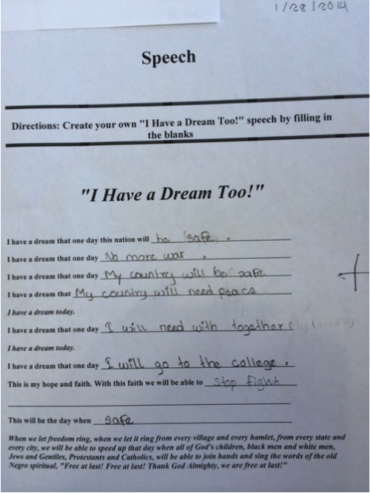
Figure 4. Student example of "I Have a Dream, too" speech showing their own goals for the future based on the format of the speech.

They then had to rehearse their speeches to prepare for a formal presentation to the class later in the week and really try to capture the emotion of Dr. King’s speech using cadence and intonation. When they did their presentations, all but two had some of the speech memorized and were able to actually present it to the class rather than read it to them. I really felt like this activity was a great success in getting students to read a more challenging piece (although they had heavy scaffolding through our discussion and my clarification during the reading to help them) and in getting them to begin to think critically through the process of applying the speech to their own lives and thinking about their own dreams and goals. Additionally, there was an unexpected oral language benefit through the rehearsal and presentations of their own speeches that I greatly enjoyed seeing. For example, students who are typically quiet and not eagerly responsive in class willingly practiced with other students prior to presenting their speech to the class as a whole, and one student in particular, who rarely raises her hand to participate in class even volunteered to go first.
After the implementation of this activity, I revised it to include more time to analyze and to listen to the intonation and cadence of the presentation of Dr. King’s speech. My students really enjoyed the historical background of the Civil Rights movement and the current version of the activity includes a greater introduction and discussion of similar movements across various countries and cultures through the use of connections to modern events of discrimination and protest as a way to tap into an existing schema and make the resulting presentation of speeches more reflective.

Activity 2 – Photo Gallery Analysis
My second activity involved a series of photographs I selected for their images showing instances of emotion and possible connections to both obvious and ambiguous goals and copied into a worksheet that the students were to look at and answer three questions: 1. “What do you see?” 2. “How do you feel or what do you think when you look at this photo?” 3. “What is this person’s goal or what do you think he/she wants?” I presented the photos in pairs and as a last minute addition, I included one, purposefully ambiguous question to be answered after analyzing each pair, “Which one is better?” What I found was that since I tried to choose photos that were thought provoking, I got a variety of thoughts from my students. Some responses seemed to be pretty limited in interpreting what they saw in the photo and just described a more obvious response. For example, when talking about a photo of a solitary man in winter, the students wrote, “I feel cold when I see this picture,” while another wrote, “I think he wants a jacket.” Other responses were much more insightful and really considered what that man in the photo may have wanted for his children or his country. For example, one student responded with “I think he wants to work hard now to have a better life for his family” when all they could really see was a solitary man standing in the snow with a heard of sheep. Though there were some variances in student responses that could be attributed to differences in language proficiency, given the fact that students from both similar and varying backgrounds all answered the same questions about the same images on the worksheet, there was a definite difference in critical thought displayed throughout the entire group of students.
Because I had a feeling this activity would generate a variety of levels of critical thought, I knew I wanted to create a very open-ended response activity, so I decided to have students take pictures that they felt represented their own goals and American Dream. Due to a lack of a sufficient number of digital cameras and after some initial consideration about the logistics of how many cameras to buy, how long each student could keep each camera, and who they could share with and rotate the cameras to, I bought some disposable cameras and passed them out on a rotating schedule during the week. I developed them over the weekend and passed back the students’ photos and used the next week to not do any new critical thinking activity, but instead used the week to analyze their own, and each other’s, pictures. Some students’ photos seemed to be a photo of a concrete object/person that gave a more obvious insight into their goals. For example, one student took a photo of her mother, father, and brother. She reported that the photo of her family represents her desire to provide a better life for her parents who have worked hard and sacrificed a lot to bring her to the United States and give her a better life and better education.
However, other students took photos that were more difficult to analyze either because they were more abstract, or didn’t capture what they intended when they took the photo:

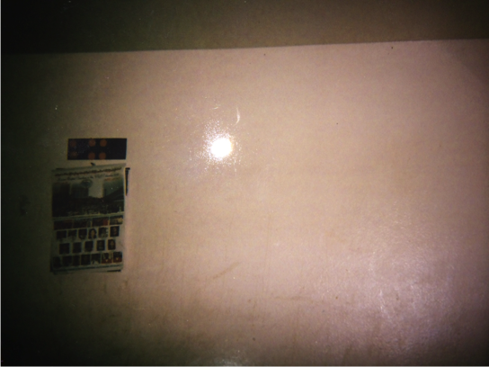
Figure 5. Student sample of photo gallery activity picture of wall with calendar showing a rather nondescript subject and goal.

For the students who had photos that weren’t as obvious in their intention of capturing an image that represented their goal, we informally discussed their intended subject and what their goal actually is. Additionally, they had the opportunity to fill out the analysis sheet for their own photo and goal in hopes that they at least understood the notion of visualizing a goal and capturing an image of it, even if they didn’t successfully capture it in their photo this time.
As a follow up activity, I had the students study another student’s photo and analyze it to determine what they felt was that student’s goal, and then pass the photo back to the owner who then filled out the same analysis sheet to answer the questions for themselves. This provided each student an insight into their own ability to capture a visual image or representation of their goals on film and an opportunity to learn a little more about their own classmates’ goals.
I did have five students who did not have a photo of their own and I had them select a photo off of Google Images that they felt represented their goals. They then exchanged computers with other students who also chose a photo off of Google Images and complete the same analysis activity as their peers. I was worried at first that the students with the Google Images photos would be at a disadvantage in critical thinking and visualizing from those with an original photo because of the fact that it would be an image that they selected rather than one they created. However, in reality it seemed they had a much easier time finding an image they felt truly connected to their goals rather than the students who had to take photos and wait to see what image they captured on the disposable cameras. It was difficult to ascertain if this was because they found a photo first and then made it fit their goals, or if it was because of the plethora of images available on Google.
One student selected a photo from Google Images that she found depicting a white, male doctor using a stethoscope to check the heart rate of a young toddler while the child’s mother looked on. All three subjects in the photo are smiling and it seems to be a very pleasant experience for all. This indicates that the student who selected this photo to represent her goal of becoming a doctor anticipates a happy and universally beneficial experience for herself, and her future patients, when she reaches that goal.
The students who chose a picture from the internet were afforded a much wider selection than those who took a picture of their own (especially if the students use disposable cameras in lieu of digital cameras where they can preview their picture) which seemed to present a disadvantage in selection options. Therefore, based on this lack of equity and the results of the implementation, the current version of the project design includes opportunities for students to do both types of photo collection, and has the students first using the disposable camera and then using Google Images as a supplemental photo to allow students a variety of opportunities to capture a visual image that represented their goals.

Activity 3 – A-G Pathway to Graduation
For this activity, I first presented my students with a chart asking for them to choose classes from a list of available classes offered at my high school. I purposefully gave very little direction and allowed the students to select as many classes as they wanted from any category (science, history, math, electives, etc.).

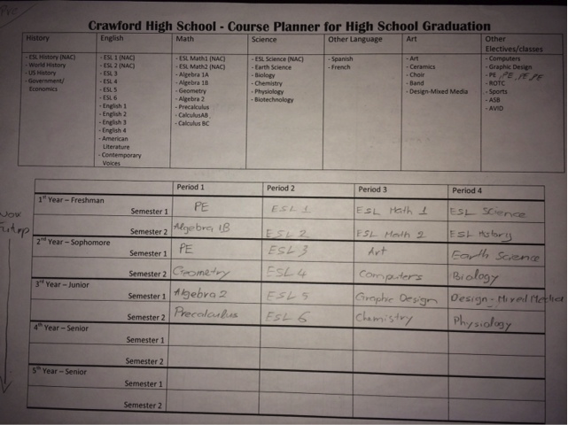
Figure 6. Student example of pre-activity graduation plan showing their choices for each year of high school. Note that the student did not include a fourth year.
After filling out their four-year schedule, I passed out an excerpt from a PowerPoint presentation and an article by the Education Trust West (2010), both included in the Appendix, and showed the students information that explained the A-G requirements, the way those requirements will now be applied to all students in this district, and the findings that this study reported that apply to English language learners (ELLs) such as them. We discussed the access to success with the A-G requirements in the past and how equity can be an issue if all students in this district don’t have access to the courses as required. We also discussed the implications of not taking the required courses and the additional obstacles ELLs have following this pathway to graduation.
After our reading and discussion, I had students fill out a second four-year plan for courses. Students immediately realized that they would need to be very strategic this time around and were much more selective in choosing the correct number of credits as required in the A-G sequence, rather than basing their choices on which classes they would enjoy the most or are already good at.

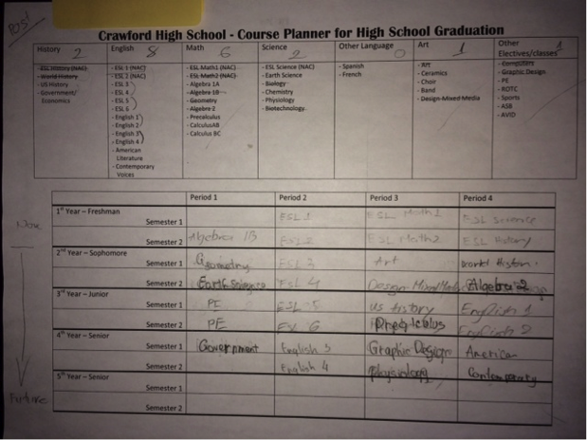
Figure 7. Student example of post-activity graduation plan showing several changes to the pre-activity graduation plan (as shown in figure 6). Note that the student now includes four years of school.
I found that most of my students were excited to make their four-year plan the second time around because they seemed to appreciate being told the “secret” to successfully moving along the pathway to graduation and college readiness. One student actually told me “Thank you for telling me this” and another asked me for an extra chart she could take to her brother (a sophomore) to fill out. A change or addition needed is to include even more time for discussion and possibly a connection to students’ home countries, as well as an area to include other considerations for high school graduation such as: community service requirements, internships, exam requirements, extra curricular activities, etc. along with a place to include resources for accomplishing these requirements (ex. tutoring available, counseling and mentoring opportunities, etc.).

Activity 4 – Art Analysis
I showed students a painting I found that depicted a woman sitting alongside a riverbank and looking off into the distance. I asked the students to imaging what the woman might be thinking about and what she may want or have as a goal. I then showed them a picture of a sculpture that is a woman standing on one leg with her body stretched out and her arm reaching out for something. I asked the students what they thought that woman was doing and what they thought her goals were. In both images, students had to imagine themselves in the position of the subject of the piece and think about what that person’s goals were in that moment which really asked them to visualize themselves in that role.

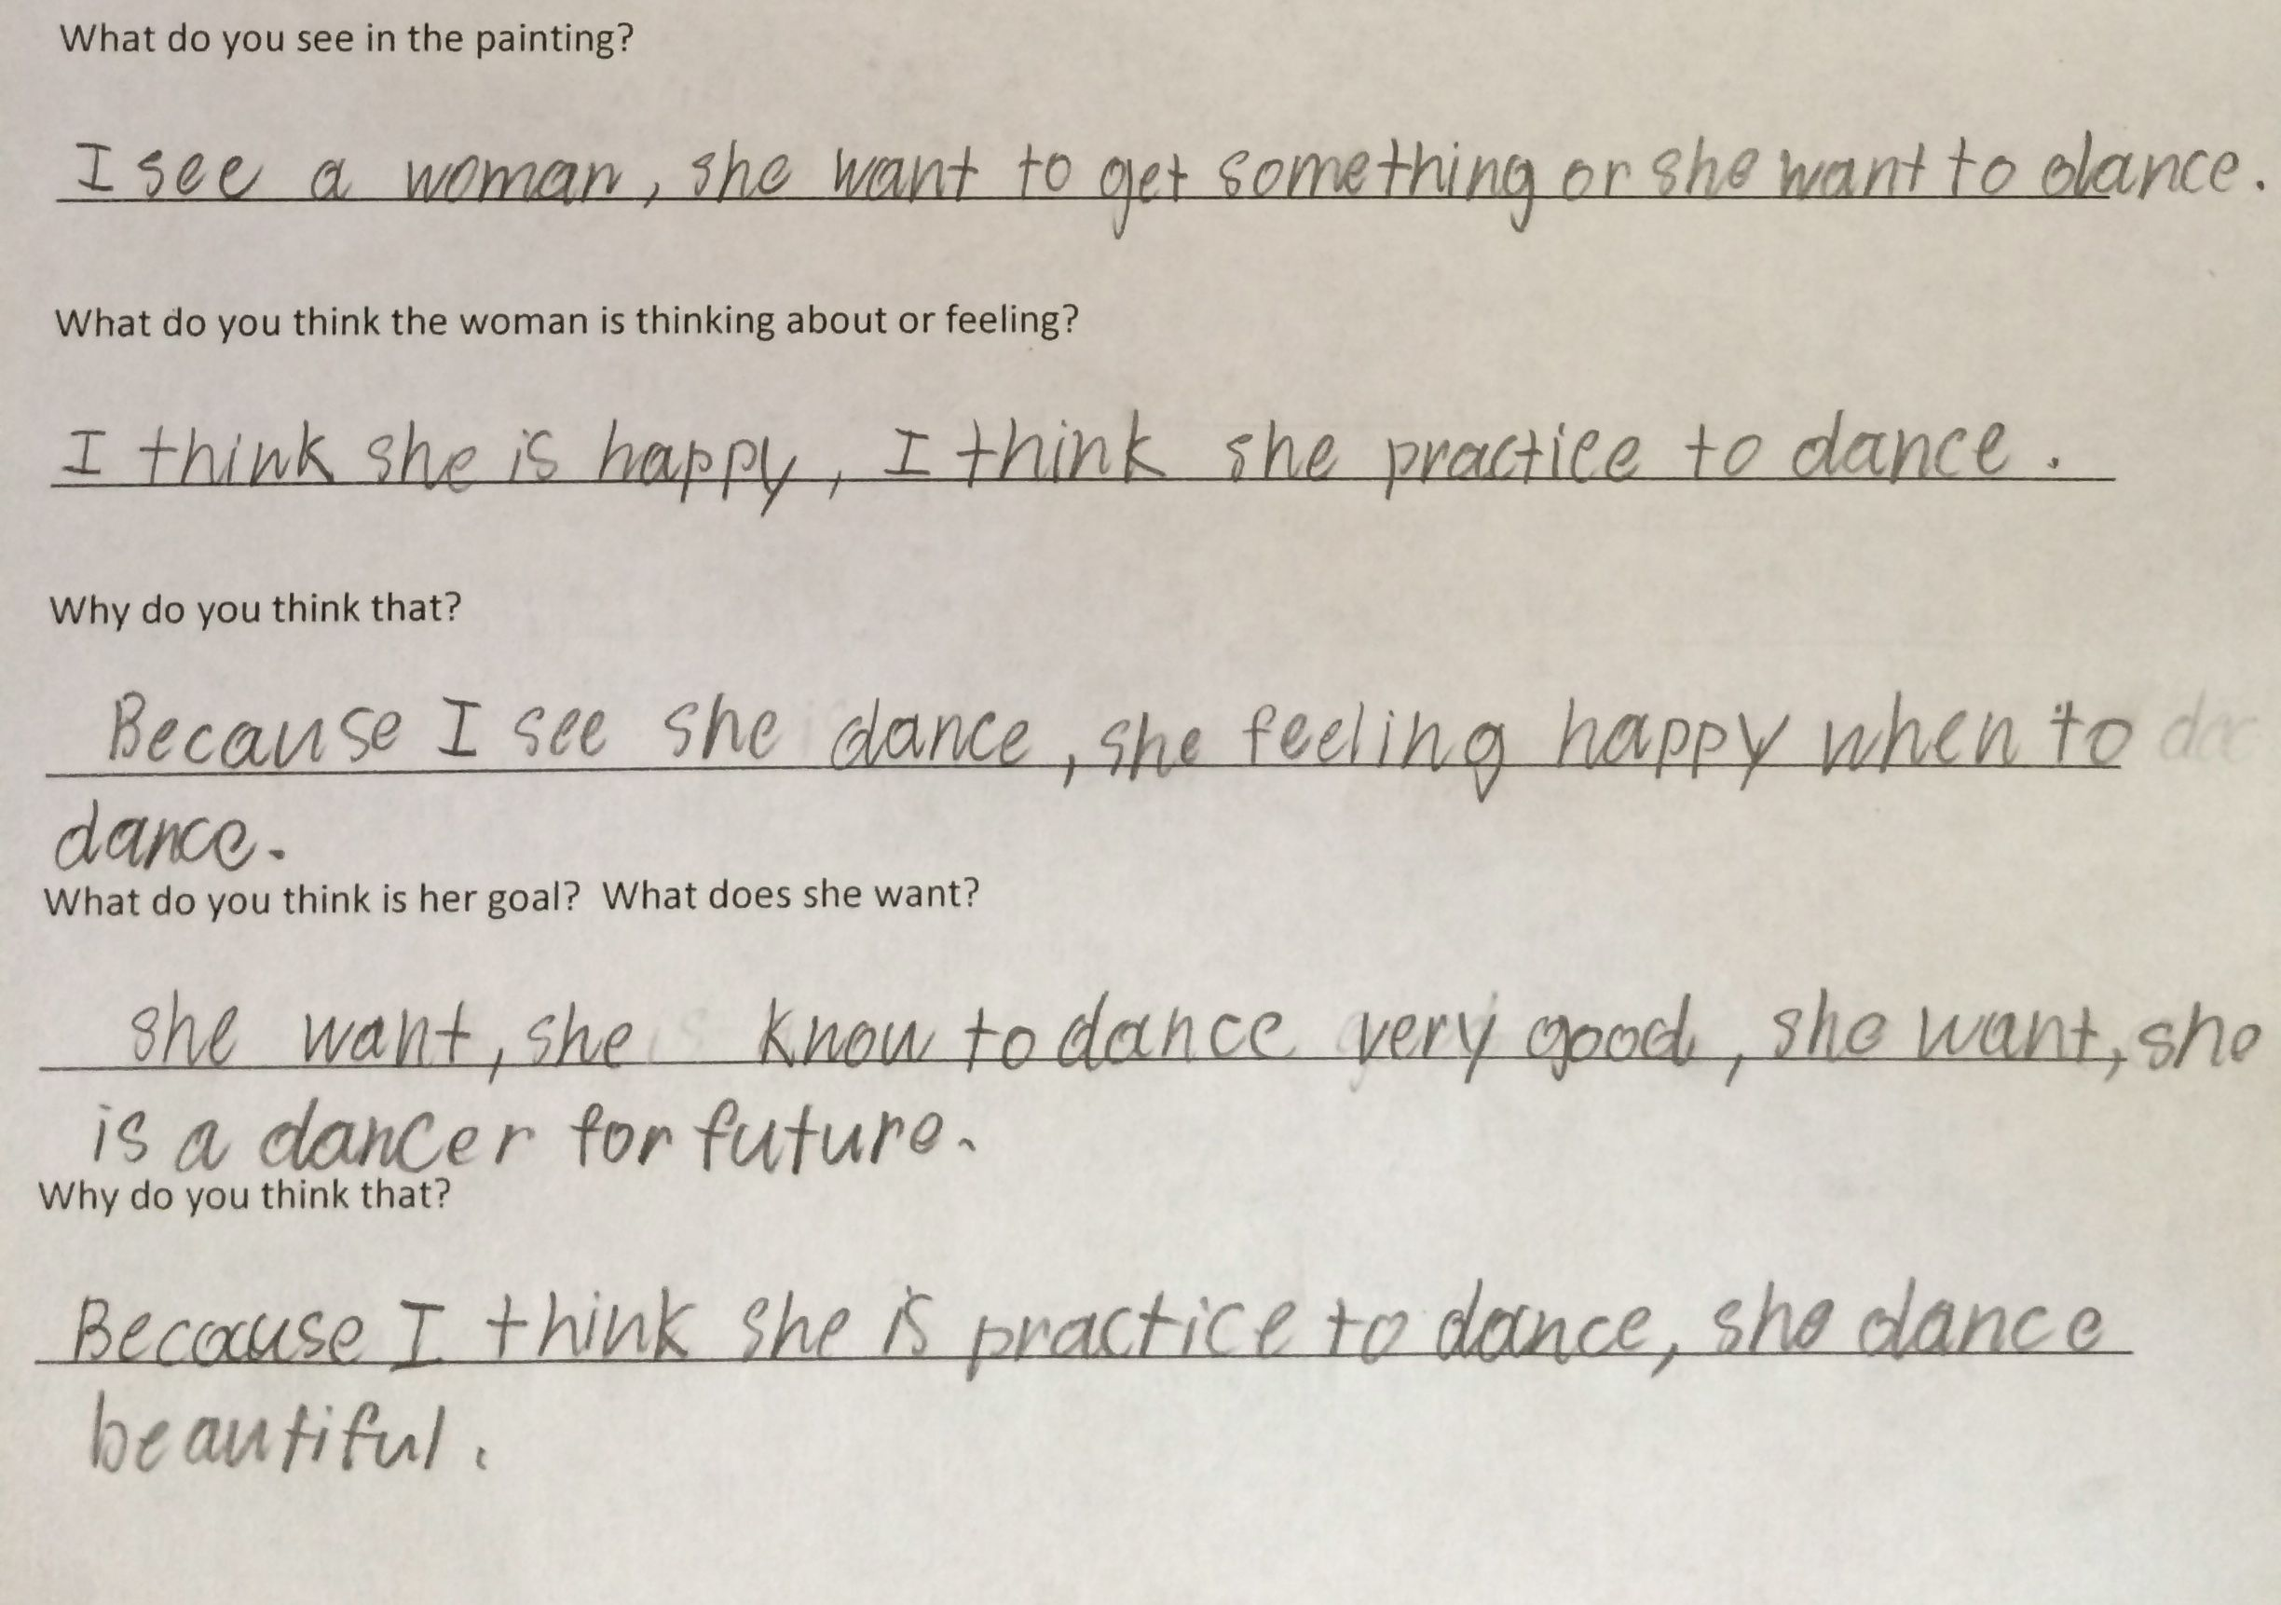
Figure 8. Example of student response sheet for art analysis displaying the student's thoughts about the subject's goals for the future. The student was responding to a picture of a sculpture of a woman reaching off into the distance toward some unknown item.

Later that week, I had the students think again about their own goals for the future and I reminded them about the two pieces of art we had previously studied. I then explained that the students would be first sketching and then creating a piece of art that attempted to demonstrate their own goals through the subject of their piece and that they could choose to do either a sculpture or a painting. I purposefully avoided giving direction about changing painting (watercolor or acrylic) methods, and didn’t direct anyone to sit in a particular grouping because I wanted to promote autonomy of artistic choice and didn’t want to give explicit direction or make students feel as if this were an assignment rather than an expressive opportunity.
All but three students chose to paint, and of those that chose to sculpt their goals, only one student created a sculpture that resembled her sketch and seemed deliberate, whereas the others sculpted and then started over several times with different designs each time until ultimately running out of time and settling for an object that did not relate to their original sketch.

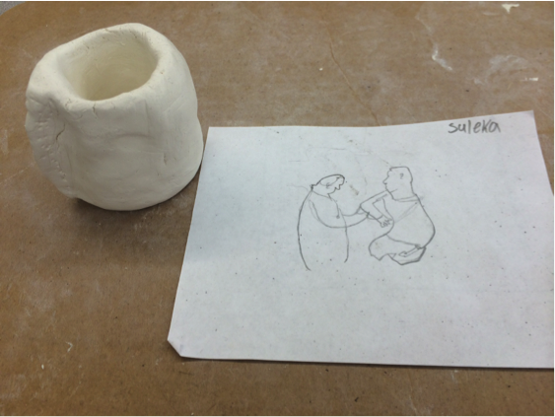
Figure 9. Example of student planning sheet and art response representing her goal. Note the disconnect from the original plan representing her goals and the actual sculpture she created.
Of the students that chose to paint, most ended up in groups that aligned with a common language and many had very similar artistic aesthetics. Despite this, I noticed that there was a lot of variation of specific details and in the choice of subjects being painted or sculpted and students were often engaged in a degree of collaboration that seemed to enhance each artist’s goals in designing and creating their piece as it related to their own personal goals. As a revision, this activity now includes a required sketch or plan prior to their painting and sculpture. I would also expect students to participate in both art activities rather than a choice between the two. Since the great majority of students chose to paint, I would like to see students do both to see how their original sketches match up to each type of artistic expression rather than having them create a piece of art that, by default, represents their goal because that is all they could come up with.

Activity 5 – Graphic Storytelling
For this activity, I had students begin by discussing the idea of goals as we’ve developed them over the previous activities. We then looked at the cover of the book, More Than Anything Else by Marie Bradby (Bradby, 1995) and I asked the students to predict what the goals were for the boy depicted on the cover who was wearing torn and ragged clothes and sat on a tree trunk looking off into the distance looking melancholy. They suggested things like, “I think he is sad,” or “He wants to see his family.” One students even said, “I think he wants an education,” which was pretty close to the truth.
We then started reading the story as a whole class and pausing frequently to clarify and examine instances of figurative language. Although the language was a bit challenging for most of the students, through discussion and some peer translation and tutoring, the students were able to connect with and understand the story of the young boy who had a goal of learning to read. It was my intent to encourage my students to use their primary language for the purpose of documenting their initial thoughts if a lack of English proficiency would hamper them from critically thinking about the story. Furthermore, research shows that using a student’s primary language in such specific, targeted instances can help them better understand directions, pay attention to elements of language structure, and improve metacognitive strategies (Goldbenberg, 2013) which will also allow them to better engage in critical thinking activities such as these.
After we finished the story, the students answered guiding questions that helped them begin to think about their own goals and what they want ‘more than anything else’. I then instructed the students to begin writing their own stories in the same style as the book by including a description of what they want (their biggest goal), how they will achieve it, and who might help them. To extend the activity, I asked the students to also include a description of what they think they will do once they have achieved their biggest goal. Students were encouraged to be as descriptive as possible and to be specific in coming up with a plan for achieving that goal and their thoughts on what they will do after achieving it.
After planning their stories, they then typed them up on computers and included a visual (either a photo or a drawing) that helped them tell the story of their pursuit of their biggest goal. They were instructed to not only describe their goal, but to create a visually rich story about the main character, themselves, as the protagonist who is working toward an important goal. Their stories and illustrations were collected and used to create a class book that is available for any student to read.

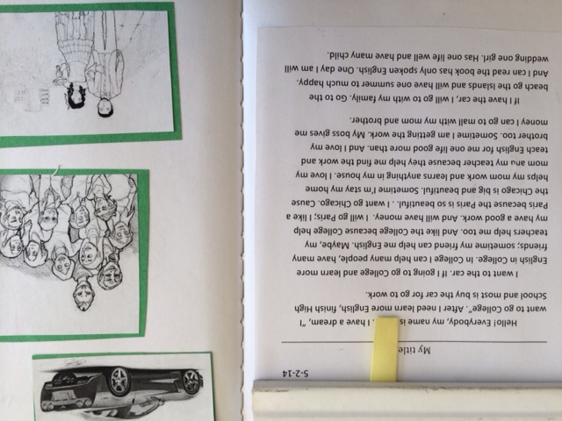
Figure 10. Picture of one student's story describing their future goals and plans to achieve them taken from the finished class book. Though there are obvious grammatical and mechanical errors, this student was able to successfully write three paragraphs explaining their goals for their future and how they think they will be able to accomplish them.

Summary of Approach
The design of Thinking in English came from a noticeable void in curriculum that simultaneously addresses the vast language learning and critical literacy development of high school students with interrupted formal education (SIFE). It was designed and implemented to support both of these needs through a dual approach of receptive and expressive tasks that are centered on a common theme of goals as a way to help student better understand and navigate through the system of education in the United States. By completing the series of five activities, students explored the notion of goals through a variety of modalities that guided them to a better understanding of their own personal objectives within a context of their new environment.

CHAPTER VII: EVALUATION OF THINKING IN ENGLISH

Research Questions and Goals
The main focus of this project was in the area of critical thought with refugee English learners, and in researching and exploring this notion I designed this curricular innovation in hopes of addressing the following research questions:
- What happens when students with interrupted formal education and limited English proficiency are challenged to think critically?
- How will students with limited English be able to express critical thought about both literature and artwork, with written and oral responses?
- When students with limited English and interrupted formal education become more critically literate, how are they able to use that new skill set to help them make better decisions about their future educational and career goals?

The three goals for this project were therefore designed with a central focus on critical literacy in hopes of accomplishing the following:
- New arrival students with interrupted formal education will improve English language proficiency to enable them to successfully take part in mainstream classes.
- New arrival students with interrupted formal education will be able to develop critical literacy skills that will enable them to build and use higher-level thinking and better understand the US system of education.
- New arrival students with interrupted formal education will demonstrate skills that indicate they will understand how to make better academic decisions about coursework, graduation requirements, and college and career planning.

In an effort to evaluate the effectiveness of the activities in this project, I collected and analyzed data from a variety of sources. In addition to field notes, or notes on direct observations, on discussions and questions that arose during each activity, I took anecdotal notes, or notations about my own impressions on the observations (Hubbard & Power, 1993), on particular students who represent a variety of language proficiency levels to gain insight into how language may or may not affect critical thought and response.
I also collected the response sheets (available in the Appendix) for each activity and analyzed them based on language level and type of critical thought for each quick response. These quick responses were helpful for both the students and for me in keeping a record of their thinking as we worked through the understanding of each activity. Additionally, this collection of quick responses helped me establish a pattern of increasingly complex thought as well as helped me to direct and inform each of the revisions to the subsequent activities.
Furthermore, each receptive activity included one response “mini-project” where students were required to apply the receptive task to their own life and goals. Each of these mini-projects included an opportunity for students to take the format of the receptive task (a speech, a photograph, an expository article, an art piece, a graphic story, etc.) and use that same medium to explore and share their own goals. Students wrote and presented “I Have a Dream, too” speeches and took photos that represent or symbolize their own goals for the future. They also wrote their own graphic stories, created artwork that represented a personal goal, and wrote a high school graduation plan (based on an A-G requirements article) as mini-projects that helped them explore and apply their thoughts and ideas surrounding their own goals and dreams.
Finally, students completed an end-of-unit culminating project that incorporated elements from the five mini-projects into one final presentation. Students synthesized their work in the area of goals and goal setting into a comprehensive examination of their own goals for their academic and/or future career. This culminating project helped students use their improved language proficiency and critical literacy in a very practical and productive way and apply their improved critical thinking skills to themselves and their own lives. The relationship between each project goal and each source of data is shown in Table 2:
Table 2. Goals and data collection strategies.
New Arrival students with interrupted formal education… | Strategy 1:  Oral and written language assessments. | Strategy 2:  Field and anecdotal notes from class discussions | Strategy 3:  Quick responses during each receptive task | Strategy 4:  Expressive mini-projects based on each receptive task | Strategy 5:  End of Unit Project
Goal #1:  … will improve English language proficiency to enable them to successfully take part in mainstream classes | X | X | X | X | X
Goal #2:  … will be able to develop critical literacy skills that will enable them to build and use higher-level thinking and better understand the US system of education. |  | X | X | X | X
Goal #3:  …will demonstrate skills that indicate they will understand how to make better academic decisions about coursework, graduation requirements, and college and career planning. |  | X |  | X | X

Field and Anecdotal Notes
During each activity, there was an opportunity for discussion and insightful conversations between both the students and myself, as well as among the students themselves. I took copious notes of both direct observations and of my own impressions and insights of these discussions during both opportunities so as to try to capture the level of critical thought during this spontaneous and unscripted response time. To analyze the notes, I coded them using the following categories: PA for an instance of personal application to their own life or experience, FT for an instance of consideration or reference to the future, JG for an instance of a judgment placed or used in discussion, and OT for an instance where the comment or question was off topic to reflect examples when the student was thinking about topics not included in our current discussion and not connected to future or personal applications.
In analyzing the field notes, I noticed students sharing insights with each other during this time and asking thoughtful questions about the content and about their written responses to the individual activities. There were some instances of students being off topic, for example when a student joked that the female subject in the picture of the sculpture (available in the Appendix) was dancing and several students began discussing who is a better dancer or what kind of cultural music they like best.
However, anecdotal observations reflected a primarily engaged class who moved the discussion beyond the original topic presented to support reflection of critical engagement.

Figure 11. Transcribed conversation with student about student’s interpretation of a photo and the goals of the subject of the photo.
*During a class discussion about the goals of the subjects in the Photo Gallery activity, a female student, Bella (a pseudonym), who is from the Karen ethnic group of Burma, and I had the following conversation:

Bella: I want to be like this one (indicating a photo of a person in a hospital bed with a beaten and bruised face).
Class: (laughs)
Me: Why?
Bella: I want be because they want education and freedom.
Me: How do you know she wants education and freedom.
Bella: Because she fights for it!

I was intrigued by the interaction presented in Figure 11 for a couple of reasons. I found it exciting to learn a little more about how students from other backgrounds see and interpret understandings about the people and the world around them. In my mind, knowing that the subject of the photo is a well-known advocate for the education of girls around the world, the picture was obviously connected to issues with gender and power or dominance. However, to hear this female student claim she wanted to be this girl, despite the intimidating injuries shown in the photo, simply because she too is willing to fight for education and freedom was amazing and inspiring to me. I was also thrilled to engage in this critical thinking opportunity through open discussion, especially in a group setting where other students may begin to see that it is okay to question and challenge assumptions.
Through my field notes and observations, I also was able to document the total number of student responses in my notes over the course of the various activities to show the levels of participation and critical engagement. As students responded in a variety of ways during the implementation of these activities, I made note of who was responding and was able to try to encourage those that weren’t engaging in the activities to begin to do so in ways that were socially comfortable to them.

Receptive Task Responses
During each of the five activities, students had a response sheet to guide them to document their thinking in that moment rather than waiting until the expressive task to begin keeping track of their thinking. These responses were tailored to each receptive task and were designed to guide students to critically think about the receptive task and how it related to their own goals. In the second activity, students filled out the receptive task response to document their thought about each image before later completing the expressive task of creating their own photos.
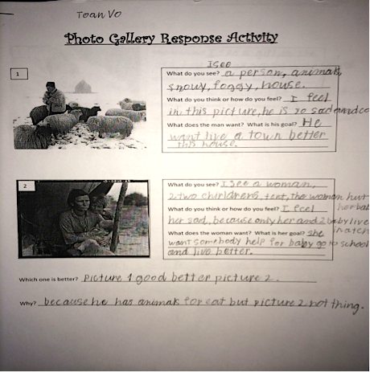
Figure 12. Student example of receptive task response sheet for Photo Gallery activity showing their reactions and analyses to the photos selected to initiate their thoughts and a discussion about goals. The first photo depicted a sheepherder standing in a cold, snowy field with a herd of sheep surrounding him and a small hut in the far distance. The second photo showed a Depression-era scene of a woman and her two disheveled children sitting under a raggedy canopy.

In the figure 12, there are two photos each with a series of questions asking, “What do you see? What do you think or how do you feel? What does [he/she] want? What is [the person’s] goal?” The questions were written to give students the opportunity to document their responses to the photos while beginning to develop critical thought about each image. Furthermore, each photo was specifically chosen to elicit responses oriented on goals so the students would begin to help them start thinking about their own goals.
Through all of these response activities with guiding questions, students were able to demonstrate an initial level of critical thought, despite their language limitations that may have otherwise prevented them from feeling competent in expressing their thoughts in English.

Expressive Task Mini-Projects
Each activity also included an expressive task that gave students the opportunity to use each type of receptive task as a springboard for additional critical thought. For example, after reading and analyzing a speech, they were challenged to write a speech of their own that gave them the opportunity to extend their thinking.
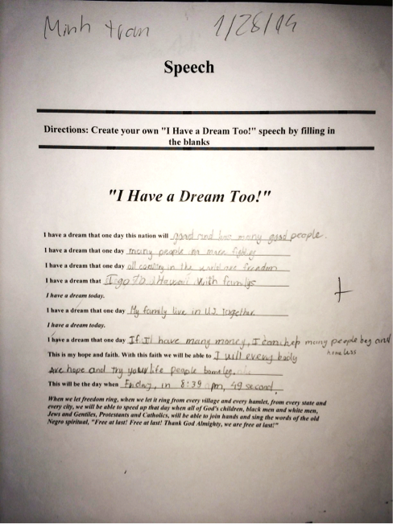
Figure 13. Example of student's "I Have a Dream, too" speech displaying this student’s goals and dreams for the future based on the format of the speech.
After studying photographs and analyzing them for symbolism or representations of goals, students took photos of their own that they felt represented their own goals.

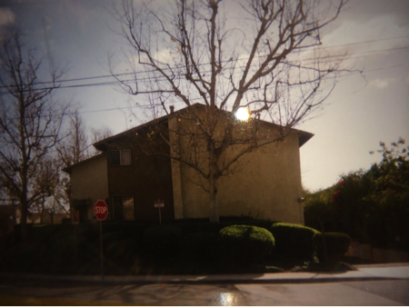
Figure 14. Student photo of goal showing a picture of an apartment building.

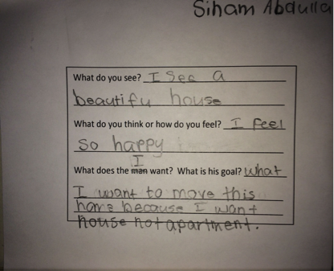
Figure 15. Student explanation sheet of the goal photographed in figure 14 demonstrating her ability to capture an image that represented a goal for her future.

For students who were absent or unable to take a photo that represented their goals, they were able to use “Google” and search images to find a picture that they felt represented their goals. One student chose a photo of a woman dressed in a traditional Indian sari adjusting the collar of a young girl, presumably her daughter. Both are standing in the center of a large, concrete drainpipe and are surrounded by trash, stray animals, and other aspects of a slum. This student interpreted the goals of the woman and daughter by using her own experiences living in a similar setting to draw from.
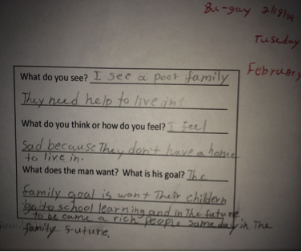
Figure 16. Student explanation of the goal of the figures in the image she selected from Google depicting an Indian woman and her daughter.

Students also wrote graduation plans as part of an expressive activity after reading excerpt from a study on the new graduation requirements in this school district. They wrote plans both before and then after being presented with the information about requirements and were encouraged to change their plan if they chose to. The following is an example of the before and after graduation plan from a student who made changes after reading the excerpt from the Ed Trust article:

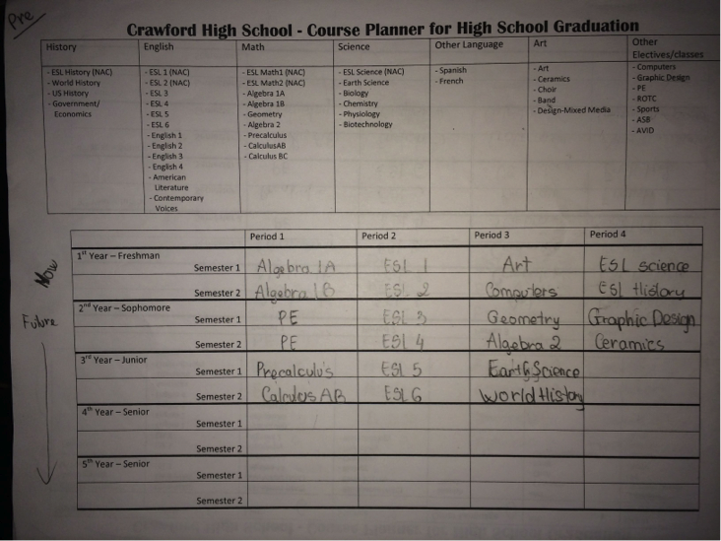
Figure 17. Student pre-activity planning sheet for high school graduation showing an incomplete four-year plan.
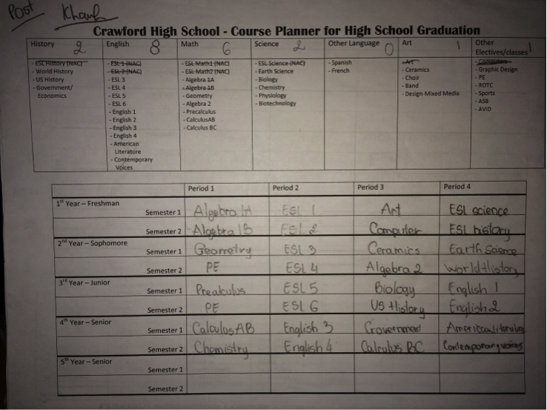
Figure 18. Student post-activity planning sheet for high school graduation showing a fully completed four-year plan with changes to selected courses.

In the pre-activity schedule (figure 17), the student only selected courses through part of their third year. The courses selected included only English as a second language (ESL) classes and very few science and history classes. In the post-activity schedule (figure 18), that same student revised their plan for graduation to include a fourth year of study with four additional English courses along with two additional science and two additional history courses to meet the requirement for graduation. The revisions were not dictated by the teacher and were completely done at the student’s own choosing after participating in the reading and discussion of the implication of the full A-G course requirements.
In the Art Gallery response activity, students were given the opportunity to create either a painting or a sculpture that represented their goals. Although all but three students chose to do a painting, it was a choice that represented their preference in representing their goals artistically and each student created a plan for their piece before beginning the creative process.

End of Unit Project
For the final expressive activity, students wrote their own stories about achieving their goals based on the book, More Than Anything Else by Marie Bradby, (Bradby, 1995). In writing their stories, they needed to incorporate elements from all of the previous receptive tasks, including incorporating photos or artwork that visually represented their goals, and adding a plan for how they will accomplish their goals.
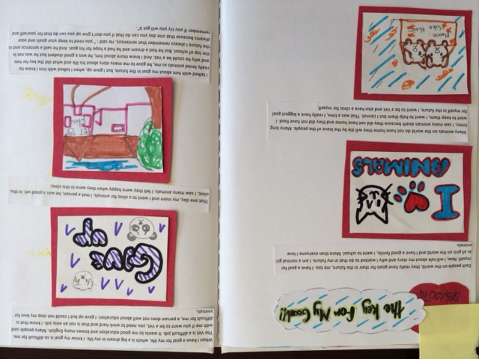
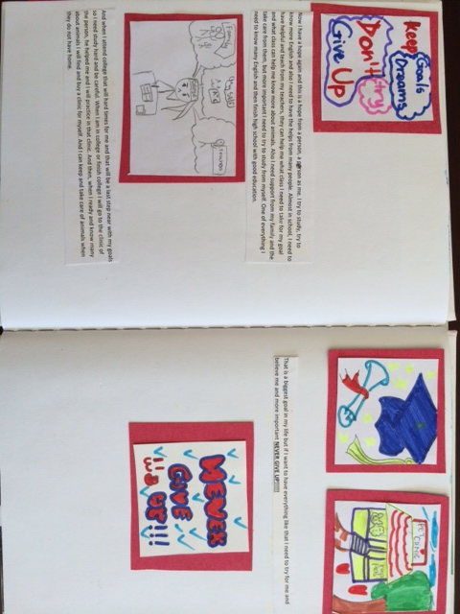
Figure 19. Two-page example of a student's story about her goals and plans for the future. This student independently decided to add additional paragraphs and pictures to her story to further explain and describe her goals.

Students also presented their stories to give them the opportunity to orally demonstrate both their English proficiency and critical thinking through the sharing of their goals. During the presentations, students stood at the front of the class and were encouraged to tell their stories much like an animated storyteller would. The students were also videotaped so they could watch their own performances at a later date.
The other students served as an audience during the each other’s presentations and were given the opportunity to ask questions at the end of each one. Their questions demonstrated an increased English listening ability and a greater level of critical attention to the content of each other’s presentations through thoughtful and appropriate questions. For example, after one boy stated that he wanted to become a pilot like his deceased father was, another student asked him, “How do you become a pilot? Do you go to college for it?” Another student struggled to pronounce some of the words in her presentation, and one of the nearest audience members spontaneously whispered the words quietly as she struggled with to assist her.
Through this final activity and presentation, students found an increased proficiency in all areas of English development, including reading, writing, listening, and speaking. However, in addition to these gains, they also furthered their overall critical literacy, self-advocacy, and sense of community.

Use of Rubrics
Each of the receptive short answer response activities were evaluated with a rubric I created to assess the overall critical thought demonstrated in the students’ responses. The rubric measured varying levels of critical thought as shown by students with wide ranges of English language proficiency. There is a five-point scale with levels that range from no critical thought to deep thought with personal application and can be used universally with each of the activities, regardless of the number of questions and response prompts.

Table 3. Rubric I created that was used to measure critical thought on receptive tasks, also available in the Appendix.
Rubric for Critical Thought (used on all receptive activity responses):
0 | No Answer
1 | Nonsense, unintelligible, incomplete, unrelated answer
2 | Answer without insight (copied)
3 | Answer with partial insight
4 | Answer with some insight and some personal application
5 | Answer with deep insight and personal application

Additionally, each activity also included an expressive mini-project that served as an extension to each receptive task. The expressive activities were varied from each other and therefore a unique rubric was designed to accompany each mini-project to assess both the level of English proficiency and the depth of critical thought. These rubrics used a four-point scale for both a measure of English proficiency and for and assessment of the depth of critical thought demonstrated in that particular expressive task.

Table 4. Rubric I created for the Art Response expressive activity, showing increasing levels of clarity of representing their goals through the art piece students created. Also available in the Appendix.
Rubric for Art Response – Expressive Activity
1 | 2 | 3 | 4
Student created something, but it doesn’t show a clear subject or goal | Student created something, but it only vaguely shows a subject or goal | Student created something, and it shows a pretty clear subject or goal | Student created something, and it definitely shows a clear and original subject or goal

Findings

Goal #1
New arrival students with interrupted formal education will improve English language proficiency to enable them to successfully take part in mainstream classes.

Finding 1:
Students demonstrated engagement in activities and showed improvement in the level of their proficiency in three modalities of language proficiency: speaking, reading, and writing.
Students were excited to complete activities and often stayed late during breaks or during lunch to complete them. Furthermore, during each activity, they asked many questions and thoughtfully completed activities by ensuring that they finished each activity thoroughly with more care and attention to detail.
At the time that the first activity was implemented, the average oral language score for the thirteen students was a Beginning level as measured using the ADEPT (A Developmental English Proficiency Test) assessment of oral language (Chavez, 2013). This assessment examines students’ oral receptive and expressive language through a series of questions administered in a one-to-one session with a teacher. The questions include everything from basic questions identifying simple objects to more intricate questions using various verb tenses and complex syntax. Students then receive a numeric score that is correlated with a language level. Students are tested at one level (from beginning, early intermediate, intermediate, and early advanced) and if they meet the benchmark for that level, they continue on to the next level.
When designing all five of the activities for the Thinking in English curriculum, I carefully considered how oral language could be incorporated into the activity to further the development of my students’ critical literacy. With both sociocultural theory guiding the incorporation of opportunities for students to learn from each other (Lantolf, 1994) and ecocultural theory demonstrating the importance of peer interaction in a sustainable routine (Weiser, 2002), the inclusion of multiple instances of peer or group discussion was integral part of the activities and during general classroom instruction. In each receptive task of all five activities, students were asked to informally, orally share their thoughts and ideas with a partner or small group before then being asked to share additional thoughts with the whole class. In addition, the first and fifth activities included a formal presentation where students demonstrated their oral and critical literacy proficiency.
Each student in the class showed improvement from their scores in January to June, as illustrated in the following table:

Table 5. ADEPT scores for January 2014 and June 2014
Student Initials | ADEPT Score: January, 2014 | ADEPT Score: June, 2014 | Change in Levels:
AA | Beg-30 | Early Intermediate-30 | + 1
SAA | Beg.-51 | Intermediate-19 | +2
KT | Beg.-28 | Intermediate-20 | +2
NS | Beg.-50 | Early Intermediate-31 | +1
SA | Beg.-9 | Beg.-41 | +.75
BG | Beg.-54 | Intermediate-19 | +2
KMP | Beg.-9 | Beg.-27 | +.5
WM | Beg.-28 | Early Intermediate-30 | +1
MT | Beg.-19 | Early Intermediate-27 | +1
TV | Beg.-19 | Early Intermediate-29 | +1
YM | Beg.-38 | Early Intermediate-26 | +1
KBP | Beg.-16 | Early Intermediate-30 | +1
GS | Beg. 38 | Early Intermediate-29 | +1

Furthermore, students showed increased scores from the first oral presentation to the final presentation as evidenced by their scores on a rubric I designed using key features of oral language proficiency such as pronunciation, voice, eye contact, and content (see Appendix). Each performance required students to discuss their goals for their future during a formal presentation in front of the entire classroom, and although not required to have the presentation memorized, it was encouraged. Despite student admissions of nervousness and lack of confidence, the quality of presentations increased in nearly all students who participated in the presentations. This increase in quality was equally distributed among the four categories as measured in the rubric.

Figure 20. Student rubric scores for oral presentations in January 2014 and June 2014.

In addition to the gains in listening and speaking as demonstrated in the above table and figure, students also showed improvement in reading and writing. Reading fluency and comprehension are measured periodically throughout the year using Running Records, which are sessions where a student reads to an assessor (usually their classroom teacher) who documents fluency and accuracy, along with comprehension. The assessor begins with a baseline reading, and if the students measures above the required benchmark, they continue until that benchmark is no longer met. After the assessment is analyzed, the assessor assigns each student a letter (beginning with level A and continuing through the alphabet) that corresponds to a reading level that would be a representation of their approximate reading fluency and basic comprehension level. In level A, a student reads at beginning Kindergarten text level and by level C a student is considered exiting Kindergarten level. Continuing, in level D a student is a beginning first grade level and continues to level J which is an exiting first grade level.
Prior to the first activity, Running Records were administered to all students and repeated again at the end of the year. Every student either improved or maintained their reading level as documented in the following table and though none of my students were assessed beyond a late first grade level, several made significant improvement from January 2014 to June 2014:

Table 6. Running Record Scores from January 2014 and June 2014 demonstrating improved reading levels in all students.
Student | Running Record:  January, 2014 | Running Record:  June, 2014
AA | C | D
SAA | D | I
KT | F | I
NS | D | F
SA | B | C
BG | G | J
KMP | B | C
WM | D | G
MT | D | F
TV | E | H
YM | D | F
KBP | D | G
GS | E | I

The letters under the January 2014 and June 2014 headings in the above table represent that student’s level on the Running Record assessment given at that time. Although an increase in one letter does not correlate to a full grade level increasing in reading proficiency, each increase in the letter score result does indicate an increase in overall reading proficiency in areas of fluency and comprehension. These letters can be aligned with grade levels with the approximate correlations where level C is the end of the Kindergarten year, level J is the end of the first grade year, and level P is the end of the second grade year. Although none of my students scored above a second grade reading level, this Running Record assessment does go up to fifth grade.

Goal #2:
New arrival students with interrupted formal education will be able to develop critical literacy skills that will enable them to build and use higher-level thinking and better understand the US system of education.

Finding 2:
Students demonstrated an increase in critical literacy as evidenced by the increase in specificity in expressed goals.

Prior to the first activity, I asked the students what their short and long range goals were. The top three answers were: good grades, go to college, and learn more English, but when I informally asked them for more specifics, they were unable to really explain or describe more details about their goals. For example, one student responded with “I want to go to college school” when asked about which college she wanted to attend, and another boy answered my question about how he will learn more English with, “I can speak English”. Since I am defining critical literacy as going beyond simply relying on the acquisition of understanding through reading, but instead incorporating social and cultural contexts into a deeper meaning, I wanted students to apply their new understanding about how to set goals for their future to the specific contexts of their own lives.
During the fifth activity, students were asked to write an entire narrative about their biggest goal, including a description of how the main character (themselves) would be able to self-advocate to achieve their goal. Every student was able to write their narrative to describe details about their goal and how they would accomplish it and include illustrations to further highlight their story. Additionally, each student also gave a presentation to the class where they read their goals story and explained the accompanying artwork.
During the presentations, students were much more specific in describing the goals they had for themselves, and in giving more concrete steps they planned to take to achieve their goals as noted by their scores in the area of content of the presentation. Whereas on the first discussion of goals students often defaulted to statements like “I want to learn English” or “I want to go to college” as their goal, however, on this final activity those statements become much more indicative of higher level thinking.
One example of an increased awareness of goal setting was during a student’s final project included a detailed expression of his goal of being a pilot and the fact that his deceased father was a pilot in his native Somalia. This is a particularly poignant example because this same student originally stated his goal for the future as simply “learn more English” and by the end of the project he had written and presented three full paragraphs about his goals and how he planned to accomplish them.
Another student told of her desire to be a veterinarian and her plan to complete the requirements for graduation and go to a university and a veterinarian school to make her parents proud when she had originally stated that she wanted to graduate and go to college. Still another student wrote about his goals to live and work in Paris, a city we’ve neither discussed nor learned about in class, and that he wanted to also take care of his family and help people in his country, showing his ability to set individualized goals while also demonstrating a level of compassion and empathy for those in the greater context of his community. Yet another student included his goals of making a lot of money and being a car designer and took the time to ask both his peers and me how he could do that. After some discussion, he realized the fact that he would need to study engineering at a university and incorporated that notion into his story and presentation. All of these examples, along with the overall class performance on this culminating activity, are indicative of the students’ making more specific goals for themselves, and thinking critically about what they needed to do in order to achieve their goals.

Finding 3:
Students demonstrated an increase in critical literacy as evidenced by their performance on the progression of receptive tasks.

For each of the activities, there were receptive activities where students read a piece of text or studied artwork and gave an immediate written response. Their responses to each receptive task were then scored on a rubric (see Table 7) designed to measure the level of critical thought displayed by personal connections and insight beyond direct recall or comprehension responses in their answers to the various prompts. Since critical literacy is a core goal of the Thinking in English curriculum, the rubric was designed to capture a range of possible responses on the spectrum of critical thought. As Park (2012) describes, visualizing and making connections in the text to oneself leads to learning which, in turn, leads to a deeper understanding of both the word and the world, and this rubric was specifically created to capture the students’ increasing ability to do so.

Table 7. Levels of critical thought displayed in responses to assess developing critical literacy.
No Answer
Nonsense, unintelligible, incomplete, unrelated answer
Answer without insight (copied)
Answer with partial insight
Answer with some insight and some personal application
Answer with deep insight and personal application

Of the original 13 participants, critical thought from the first to the last activity increased in seven students as measured on their rubric scores, and remained the same in five of them despite an increase in the cognitive demands for the final activity which took place at the end of the school year. In fact, the only student whose critical literacy score went down did not actually complete the final activity due to a visit to the nurse’s office for a hearing screening.
During the first activity in January, fewer students demonstrated critical thought by giving personal examples that went beyond a basic response to the prompt. In fact, several students wrote and presented about helping their people and getting an education as being their dreams for the future. While they may have actually been interested in both of those goals for their future, they lacked a level of specificity that individually connected that goal to their own personal context and environment. By the fifth activity in June, more students were able to make a deeper critical connection to the text, More Than Anything Else (Bradby, 1995), by stating observations about the boy’s goal of learning how to read. For example, one student inferred the reason for the boy’s goal was because he was always working and didn’t have enough time to study or learn to read. This particular student also had periods of interrupted education due to family obligations and used her own personal experiences to better understand the story. Furthermore, by demonstrating an ability to set specific, personalized goals situated within their own individual contexts and on this activity, only one student scored a two reflecting the fact that she copied much of her response from a more proficient peer.

Figure 21. Student rubric scores of critical literacy from the first to the fifth activity.

Goal #3
New arrival students with interrupted formal education will demonstrate skills that indicate they will understand how to make better academic decisions about coursework, graduation requirements, and college and career planning.

Finding 4:
There are indicators of students’ growing ability to set and pursue goals and successfully navigate the system of education here in the United States as demonstrated by their increased use of wording that reflects this increased understanding.

In each successive activity, students included more markers that highlighted their understanding of the U.S. system of education. For example, in the second activity where they analyzed and took photos representing goals, one student responded three times in the same worksheet that the subject’s goal were “maybe she good goal future”. The repetitiveness and vagueness of her response does not indicate a critical understanding of the US system of education. That same student later wrote that in order to become a teacher (her goal in activity five), she would need to first learn more English, then graduate from high school, and finally go to college, demonstrating her increased understanding of the order of completing the steps to accomplish a specific career goal in the US. Figure 23 displays the increasing prevalence of wording that demonstrates the greater critical awareness of the system of education in the United States among students:

Figure 22. Indicators of student understanding of the US system of education.

Upon analysis of students’ response sheets to each activity, I noted specific instances of understanding of how the Unites States educational system functions and ways to navigate it, and rather than coding it, I noted the number of instances of this indication. For example, in the Photo Analysis activity, in response to two photos of a school in a refugee camp and a school in a westernized country, I asked students to answer the purposefully ambiguous question, “Which one is better? Why?” Nearly every student indicated they thought the second picture was “better” and in an indication of why, several students replied that the computers would help students learn and one added that the students in the second picture would be able to get a job. In this example, students are using the critical literacy skills of visualization and metacognition to draw from their own repertoires of personal experiences (Meltzer & Hamann, 2005) to make judgments and personal applications about the photos.
In the Art Analysis activity, students were asked to describe what they felt the subject of the painting or sculpture was thinking and what their goal might be. Though these prompts weren’t directly related, several students responded with answers that indicated an understanding of the US system of education. In looking at a painting of a woman on the bank of a river, one student described her goal as, “She will work hard and study. She want [sic] to get an education and a good job and more money.” In a follow up conversation with that student, he told me that in his country people have to pay to attend school and if you don’t have money you can’t go to a good school and can’t get a good job. His statement indicates he is aware that in the US, school isn’t typically fee based and that by working hard, the woman in the painting would be able to get a good education and a good job. Here, he is drawing from his own prior knowledge and making a comparison to how school in the United States is different from the system he was familiar with in his country, reflecting a metacognitive understanding of both contexts of an educational system that is fee based and one that isn’t.
To ensure an accurate comparison across activities, I averaged the number of indicators present per student for the two activities before and the two activities that took place after the third activity, which was directly focused on understanding the requirements for high school graduation. With the first and second activities, the average indication of an awareness of the educational system of the US was 1.06 per student, however with the fourth and fifth activities, that average nearly doubled to 1.89. All four of the activities measured here were designed to elicit a similar response about students’ goals and the rationale for those goals helping to ensure that the measure of increase in the presence of these indicators of understanding would be consistent across the span of activities.
Additionally, the third activity involved students completing a course planner before and after being instructed on requirements for high school graduation. Students were encouraged to made adjustments to their schedules that reflected their understanding of the requirements of this educational system and fill out the same course planner a second time. I counted the instances of change from the first and second course planner, and the results are noted in the figure below:
Figure 23. Number of changes in the pre and post activity planners in different subject areas required for high school graduation. Note that the numbers along the y-axis represent the actual number of changes made in each subject area from the pre and post planners.

All but two students included at least one or more changes to their course planner, indicating the majority of students demonstrated a greatly improved understanding of the requirements for high school graduation in this system of education. I asked one student why she was making changes and taking fewer art classes. She replied, “Because I have to do more science classes and I don’t have more time in the years” describing her conscious decision to meet the expectations for graduation based on an increase in understanding of the A-G college requirements for graduation. This vignette was repeated with several other students who made similar changes to their four-year schedules where they reduced the number of physical education, art, and world language courses in favor of meeting the English, math, science, and history/social science requirements.

Finding 5:
Reflecting an increased sense of support and community, students were empowered to seek out help from one another and to offer help to each other, regardless of language similarities or differences.

Students in this environment often need great assistance in completing various literacy activities. Lantolf (1994) describes how sociocultural theory informs the practice of students effectively working in dyads where a beginning English learner is able to learn from another, more experienced or more proficient student. Ecocultural theory also supports the notion of students using their interactions with their environment, including the peer relationships within that environment, to further their own development (Bronfenbrenner, 1986). Therefore when a student arrives in my classroom, I often pair them up with another student who speaks the same language and would likely be able to help with basic translation of class routines and processes, as well as giving clarification on assignments and providing the newer student with a model for educational norms in our class. Depending on individual personalities, that assistance may be offered or requested from either the students themselves, or at the teacher’s direction.
Over the course of these activities, students showed an increase in both the number of instances where they independently sought out help from another student and the number of times they spontaneously offered assistance to classmates without a directive from me. Prior to implementation, the majority of students needing assistance on answering questions within an assignment would first look to a friend who spoke the same language and often copy that student’s answer before asking me or another student for help completing the task. Additionally, when I prompted a more experienced student to help a newer student of a different primary language, the experienced student often looked hesitant and didn’t appear to be readily willing to do so. Furthermore, without my intervention, many students would continue to work in silence and either stare at the assignment and/or look around the room in confusion rather than ask for help.
As the implementation continued, I noticed a gradual shift in the orientation of assistance being provided (see figure 24). In the absence of whole group instruction, increasing numbers of students were choosing to get up and move to a table where they would be able to work with a peer or a group to complete an assignment. Moreover, among those seeking and willingly offering help, there were more instances of students working with others from cross-linguistic backgrounds without teacher prompting.

Figure 24. Comparison in number of students seeking or offering assistance and working independently.

There were also several instances where students filled both roles of seeking out help and offering help to other students who needed it, accounting for the total numbers being higher than the total number of students enrolled in the class. For example, during the fifth activity a male student from Vietnam noticed some students struggling to type their stories and spontaneously went around the classroom offering help to his peers. Almost immediately, students began getting up and taking their laptops to him to seek help with issues like formatting and spelling, however when he realized he didn’t know how to explain that he wanted to move to Paris with his whole family, he sought help from one of the students who he knew had a high vocabulary and could likely help him complete that thought in English. This type of voluntarily cooperative environment was not evident in the early activities of this project.

Discussion
In reflecting on my students and the incredible obstacles they face in immigrating to a new country, I designed direct, task-oriented activities of the Thinking in English to help them psychologically cope and acculturate to the United States and our system of education (Ward and Kennedy, 2001). I wanted the students to be able to utilize their critical thinking through strategies of visualization (Park, 2012) and oral discourse, despite the fact that they are at the beginning stages of developing their English language proficiency so I created this curriculum to be open-ended so it could be used at varying levels of development. I also wanted this curriculum to be engaging, challenging and supportive in helping them successfully grow both in language proficiency and in critical literacy.
I also wanted this curriculum to be engaging, challenging and supportive in helping them successfully grow both in language proficiency and in critical literacy. As Hou and Beiser (2006) describe, as students gain proficiency in the language of their new land, there is a profound effect on integration and on overall well-being. As my students increased their reading, writing, and speaking skills over the course of their implementation, their confidence grew and they performed successively better on both written and oral assignments and assessments.
Additionally, by participating in each of the activities surrounding critical thinking and goal setting, students began to build a knowledge and confidence about how the US system of education works and how they can negotiate their path through it in pursuit of their own academic goals. They better understood the requirements for more immediate goals of graduation as well as ways to make more specific plans to achieve long-term career and life goals like becoming a pilot or living abroad. There was also an increase in overall advocacy in terms of seeking and offering help while completing assignments. Following a sociocultural perspective, they moved from passive participants who were told what classes to take or what goals they should have in the traditional curriculum of simply mastering a second language, to becoming active seekers and co-creators of knowledge (Lantolf and Pavlenko, 1995).
This project has proven to be a way to help students tap into their own cognitive resources available in order to help themselves and each other. I began to see students using study skills not directly taught in class, such as choosing to go get a white board to study new vocabulary or rereading a book to practice sentence structure simply because they decided they wanted to, and could, learn more. I noticed more students staying in at lunch to eagerly finish or redo assignments that were difficult and several who began to come in because they enjoyed reading the picture dictionary and challenging each other to recognize new words for fun. When work was difficult, several students spontaneously took on a mentoring position and would regularly walk around checking in on other students and offering help and corrections on their work when needed.
As students who have some amount of interrupted formal education, this project has been able to benefit them in a way that validates their varied experiences and scaffolds their thinking as they learn to apply developing critical literacy skills. As the rubric-scored responses to the various activities reflect, there has been an increase in reading, writing, and speaking proficiency, critical thinking, goal setting, and overall self-advocacy among the students in this class. Students who were unable to generate original answers on some of the initial assignments were confident and proud as they presented their final projects to their peers.
Despite a huge variance in primary languages and home countries, this curriculum has helped these students to situate their own wide-ranging strengths to being both valid and valued in the new context of learning they are all in here in the US. With this newfound boost in confidence, skill, empowerment, and sense of community, the Thinking in English curriculum has helped these students get a more solid academic foundation as they begin their new lives in the United States.

CHAPTER VIII: CONCLUSION

This project has evolved over the course of the implementation and has become one in which my newly arrived, refugee beginning English learner students are challenged, supported, and encouraged to use a platform of goals and goal setting to meet simultaneous objectives for developing more English proficiency and critical thinking skills. Burbules and Berk, (as cited in Popekewitz, 1999) describe term “critical” in education as being a goal of teachers to help students be more suspicious of commonly accepted truths in education, so as not to be deceived by the system itself. It was my hope that by supporting students in these two endeavors, an extended benefit would follow where students used their newfound critical literacy to forge a more active path for themselves in the educational system of this country in which they are now creating a new life.
In working with this unique population of students over the last several years, I have come to see their diverse backgrounds and range of experiences as such an incredible source of strength and inspiration. They are some of the most hardworking and earnest students I have ever worked with, and to see them struggle in a system that isn’t holistically designed to support and guide them has been an area of great frustration. I frequently and regularly saw students being overlooked or misdirected in classes, school counseling offices, school supported programs where they were often passive participants in decisions that grossly affected the outcome and success of their education. Most often these students did not have a strong enough command of English to fully understand conversations or written information that detailed classwork, their options for courses, the availability of community support networks, or potential obstacles. Nor did many of these students frequently have a level of competence and confidence in the English language necessary to be a self-advocate or even an active decision-maker in the educational processes they did understand. Additionally, and perhaps most importantly, the vast majority of these students didn’t have the understanding of the intricacies of the system of education and community support that would be required to know when decisions were being made that may hinder their progress or goals.
It was out of this observation that I first imagined a curriculum that would address these issues of awareness of an educational system that is foreign and difficult to maneuver. I designed the Thinking in English curriculum because I feel that teachers should be concerned about the way all of their English Learning students, especially refugees who are recently resettled, are learning English while also learning how to navigate their own education in the United States. I felt like if there were a curriculum that addressed these needs simultaneously, students would be able to set better goals for themselves and follow a more directed path in pursuit of their higher education and career goals.
I carefully researched and designed the Thinking in English curriculum to create lessons that sequentially build literacy skills in English in areas of reading, writing, and speaking. These lessons are unified by a common theme of goals so students will see them as part of a greater unit of study while participating in activities that are improving their English proficiency. Additionally, these activities utilize a specifically chosen common theme of goals that helps them to focus all of their practices on a topic that will offer them long term and meaningful benefits. Rather than use activities that are independent from each other to improve English skills, I think teachers should use activities that are cooperative and sequential in order to maximize the learning.
Furthermore, I wanted activities that would also be able to help students begin to develop critical thinking skills in English that they could apply both in a variety of subjects in school and in situations outside of a classroom. To this end, each activity was designed to support students’ in the development of higher level thinking though an exploration of the notion of goals within a variety of unique activities. Students were provided with opportunities for deep insight around the analysis of goals in speeches, photography, expository text, artwork, and narrative fiction, and used these opportunities to develop a multilayered concept of their own goals within the context of their new life in the United States.

APPENDIX

by

Skye Marie Cooke-Pinon

Overview of Contents
Letter of Introduction
Overview of Activities
Description of Constructs and Rationale that Guided the Activities

Activity One: I Have a Dream
- Lesson Plan
- Worksheets

Activity Two: Photo Gallery
- Lesson Plan
- Worksheets

Activity Three: A-G Path to Graduation
- Lesson Plan
- Worksheets

Activity Four: Art Analysis
- Lesson Plan
- Worksheets

Activity Five: Graphic Storytelling
- Lesson Plan
- Worksheets

Rubrics
- Receptive Tasks
- Expressive Tasks
- Activity 1
- Activity 2
- Activity 3
- Activity 4
- Activity 5

Dear Fellow Educator,
It is with great joy that I bring you the Thinking in English curriculum as a culmination to a year of thoughtful research and reflective teaching. I have the privilege of working with some of the most resilient, determined, and jubilant students as an English as a Second Language teacher to newly arrived students. Although my students come from all over the world and bring some of the most enduring and heart-wrenching stories I have ever heard, they also bring a great hunger for knowledge, education, and opportunity, which led me to designing this curriculum.
It was my ultimate desire to design curriculum that could help my students overcome a lack of English language proficiency and build a higher level of academic success, but what I found was that there is a need for so much more. So many of my students have struggled with not only fitting in to a new culture and a new language, but into a whole new culture and system of education. Things that are second nature to many Americans like asking questions, direct contact with authority, and meeting discrete requirements or deadlines seemed to be foreign to most of my students and these small misunderstandings became huge obstacles to their progress.
The more this happened, the more I realized that it is unfair that many foreign-born students are at a disadvantage due to a lack of foundational knowledge of the US system of education and societal structure. I felt more and more certain that if these students are given more critical thinking skills, they will be able to use those skills to help them further their progress by becoming better self advocates while learning to navigate a new educational system.
Through the Thinking in English curriculum, students will explore their own thoughts on the topic of goals. They will discover how to think critically about goals when presented with various activities and in doing so they will develop their English language proficiency while also deepening their knowledge about our educational system. Ultimately, it is my hope that the Thinking in English curriculum will be able to help students of various backgrounds, whether English learners, new arrivals with interrupted formal education, or students who have gone to US schools all of their lives, develop greater critical thinking skills and become more active participants in their own educational path.

Sincerely,
Skye Pinon

Overview of Activities
Name of Activity | Description of Receptive Activity | Description of Expressive Activity | Materials Needed | Time Estimate
I Have a Dream | Students will read and analyze an excerpt from Dr. Martin Luther King’s “I Have a Dream” speech (King Jr., 1963) | Students will write and present their own speeches entitled, “I Have a Dream, Too” where they write about their own dreams and goals | - Copy of “I Have a Dream”  - “I Have a Dream, Too” worksheet | - 1 day to read and analyze speeches  - As many days as needed to practice  - 1 day to present speeches
Photo Gallery | Students will study various photographs and answer critical thinking questions about the subjects goals for the future | Students will take photos that represent their own goals for the future and analyze each other’s photos before presenting their own photos and goals to the class | - Photo Gallery worksheet  - disposable or digital cameras for student use  - worksheet for analyzing each other’s photos | - 1 day to complete photo gallery worksheet  - As many days as needed to have all students take photos  - 1 day to analyze each other’s photos  - 1 day to present their own photos
A-G High Path to Graduation | Students will read an excerpt from the “Educational Opportunity Audit Report” regarding the A-G requirements needed for graduation | Students will analyze fairness of A-G requirements and plan their own course schedule for all four (or five) years of high school | - Copies of the “Educational Opportunity Audit Report”  - Course schedule worksheet | - 1 day to read and analyze A-G requirements  - 1 day to plan out course schedules and present to class with rationale
Art Analysis | Students will study “On the Bank of the Seine” painting by Monet and determine what they feel was the goal of the woman in the painting | Students will paint their own representation of an image or picture that represents their goals for the future | - Copies of “On the Bank of the Seine” worksheet  - paint, paintbrushes, and paper | - 1 day to analyze the Monet painting  - 1 day to paint own painting  - 1 day to present paintings to the class
Visual Storytelling | Students will read a graphic story and analyze it to see what the goals are of the person in the story | Students will write their own next chapter in their goals and life stories and present them to the class | - Copies of graphic story  - Copies of graphic story template  - Markers or colored pencils | - 1 day to read and analyze graphic story  - 1 day to write their own graphic stories  - 1 day to illustrate, color and finalize their own stories  - 1 day to present stories

Description of Constructs and Rationale that Guided the Activities

Sociocultural and Ecocultural Theory
Through these five interactive activities students are able to effectively utilize a network of experts within each other to complete each part of the activities of this project. Students benefit from moving between a novice role and an expert role (Walqui, 2006) as they help each other understand the readings, the artwork, or in creating their own responses to either. Although the activities themselves are individual, cooperation and mutual collaboration should encouraged so students feel comfortable exploring and sharing their own thoughts about the topic being read or analyzed.
Being aware of how a student’s development is affected by outside influences of their family, community, local school system, and the greater political and social climate they live in gives teachers a greater understanding of that student’s perspective and the factors that may affect their learning. This consideration allows teachers to better design lessons that are linguistically and culturally sensitive and that maximize a student’s ability to growth and cognitive development (Bronfenbrenner, 1986).

Critical Literacy
As a means of making the learning more concrete, students are taught to visualize themselves in each situation presented in the activities of this project to help them fixate their position in the role of goal-setter. As students read about and analyze artwork surrounding the notion of goals, they are taught to see themselves in that work as a means to support the opportunity for deeper thought and discussion (Park, 2012). Furthermore, according to Elbow (2005), helping students to see the relationship between themselves and the work they are studying allows for a more concrete and explicit connection to that work and the ideas presented within.
Au (1998) describes communication and discourse strategies as being key components in building meaning, thus assigning oral discourse as a key part of developing students language proficiency and critical literacy. Through their discussions and presentations on each of the individual activities of this project, students have multiple opportunities to further understand the topic of goals through the modality it is being presented in (reading, artwork analysis, etc.) and to process their own thinking on the topic. Iddings, Risko, Rampulla (2009), also describe how oral discourse can even be a key component in contributing to the overall understanding of a subject.
Having students consciously think about their own position and role in their learning helps them to internalize their progress (Baker & Brown, 1984), which in turn, helps them to self-regulate and monitor their learning activities. By doing so more effectively, students are able to make adjustments to their own learning trajectory to ensure that they are doing everything they can to progress both academically and socially. In each of these activities, the receptive task that presents students with information gives them the opportunity for a quick response with specific questions that promoted metacognitive thinking. This gives them the opportunity to immediately reflect on their own thinking and understanding as a way to make adjustments in the moment rather than moving on despite a lack of comprehension. Teaching these English language learners such metacognitive strategies in their second language helps them to begin to mitigate a potential lack of literacy in their first language that may further hamper their overall development of critical literacy and thinking (Genesee, Lindholm-Leary, Saunders, Christian, 2005).

Unifying Theme of Goals
For the Thinking in English curriculum, there are a series of five activities that utilize a variety of learning and creative styles. Each activity includes a dual-faceted approach in which both receptive and expressive tasks are given to students to challenge them to engage in more meaningful ways with content and curriculum as they explore and challenge their notion of goals and goal setting. In terms of receptive input based tasks, students read graphic novels, short stories, speeches, and poetry with a level of support and scaffolding provided that allows them to access content surrounding the theme of goals, but is flexible enough to allow critical and creative thought.
In the first activity of the Thinking in English curriculum, I Have a Dream, too, students listen to and read an excerpt from Dr. Martin Luther King Jr.’s “I Have a Dream” speech and analyze his dreams and goals before reflecting on their own goals and writing and presenting a speech of their own. The second activity, Photo Gallery Response, asks students to analyze a collection of photographs that represented subjects from a variety of backgrounds and infer what was the goal of each subject, or the photographer. They then have to take photos of their own that symbolize their goals in some way and trade photos and interpret their classmates’ work to determine each other’s goals. The third activity, A-G Pathway to Graduation, presents students with the opportunity to make decisions about the four-year series of courses they want to take while working toward their high school graduation. After planning their four years of classes, students are then given some data about the graduation rates of English learners and the recent requirement of all students completing the A-G series of courses to graduate in this district. Students are then given the opportunity to revise their planned schedule of coursework to better direct them toward a successful path to graduation. In the fourth activity, Art Response, students study two art pieces, a painting and a sculpture, to infer the goals of both the artist and the subject of his work. They then create a piece that reflects or symbolizes their own goals or dreams for the future. The final activity, Visual Storytelling, involves a visually rich picture book, More Than Anything Else by Marie Bradby, that tells the story of a young boy who desperately wants to learn to read. Through plentiful examples of figurative language and beautiful artwork, the students discover how a goal can be so all-encompassing that it drives a person to seek out help and advocate for that dream. They then reflect on their own dreams and aspirations and design a plan with steps to accomplish their own biggest goal and use that to form the basis for a narrative they write about their own goals and plans to accomplish them.

Activity One: I Have a Dream
Language Objective:
- Students will read an excerpt from “I Have a Dream” (King Jr., 1963) and write a speech of their own that tells their own dreams and goals for the future.
- Students will listen to Dr. King’s speech and identify his intonation and cadence as powerful contributors to the passion and emotion of his speech.
- Students will present their own speeches attempting to recreate Dr. King’s passion and emotion.

Learning Objective:
- Students will analyze the dreams presented in “I Have a Dream” and whether or not they feel those dreams are valid and if they have been accomplished.

Materials:
- Student copies of excerpt from “I Have a Dream” and copies of “I Have a Dream, too!” worksheet.
- Video of “I Have a Dream” if possible.

Procedures:
- Discuss history of the Civil Rights movement in the United States. Show clips of video footage from the time and discuss the reality of the discrimination and prejudice of African Americans by white people.

- Read excerpt from “I Have a Dream” and explain the figurative language and historical context and references as needed.

- Watch video footage of “I Have a Dream” and note Dr. Martin Luther King Jr.’s use of intonation and cadence in the speech.

- Reread the speech and compare moments of rising passion in his voice as tied into sections of the speech and taking time to discuss the meaning of those sections in relation to Dr. King’s goals and dreams.

- Discuss students’ own passions and goals and describe the speeches they will write that portray their goals and dreams.

- Pass out “I Have a Dream, too” worksheets and allow students time to fill in the information with their own dreams and goals.

- Schedule time for students to practice and present their speeches at a later date.
I Have a Dream
By Dr. Martin Luther King Jr.
March on Washington (1963)

I say to you today, my friends, so even though we face the difficulties of today and tomorrow, I still have a dream. It is a dream deeply rooted in the American dream.
I have a dream that one day this nation will rise up and live out the true meaning of its creed: "We hold these truths to be self-evident: that all men are created equal."
I have a dream that one day on the red hills of Georgia the sons of former slaves and the sons of former slave owners will be able to sit down together at the table of brotherhood.
I have a dream that one day even the state of Mississippi, a state sweltering with the heat of injustice, sweltering with the heat of oppression, will be transformed into an oasis of freedom and justice.
I have a dream that my four little children will one day live in a nation where they will not be judged by the color of their skin but by the content of their character.
I have a dream today.
I have a dream that one day, down in Alabama, with its vicious racists, with its governor having his lips dripping with the words of interposition and nullification; one day right there in Alabama, little black boys and black girls will be able to join hands with little white boys and white girls as sisters and brothers.
I have a dream today.
I have a dream that one day every valley shall be exalted, every hill and mountain shall be made low, the rough places will be made plain, and the crooked places will be made straight, and the glory of the Lord shall be revealed, and all flesh shall see it together.

Speech

Directions: Create your own "I Have a Dream Too!" speech by filling in the blanks

"I Have a Dream Too!"

I have a dream that one day this nation will ____________________________________

I have a dream that one day _________________________________________________

I have a dream that one day _________________________________________________

I have a dream that ________________________________________________________

I have a dream today.

I have a dream that one day _________________________________________________

I have a dream today.

I have a dream that one day _________________________________________________

This is my hope and faith. With this faith we will be able to _______________________

________________________________________________________________________

This will be the day when __________________________________________________

When we let freedom ring, when we let it ring from every village and every hamlet, from every state and every city, we will be able to speed up that day when all of God's children, black men and white men, Jews and Gentiles, Protestants and Catholics, will be able to join hands and sing the words of the old Negro spiritual, "Free at last! Free at last! Thank God Almighty, we are free at last!"

Activity Two: Photo Gallery
Language Objective:
- Students will read and answer questions about various photos.
*Note – for this activity, choosing compelling photographs that will encourage students to engage in deep analysis of the photograph, will make the activity more successful. Teacher should select photos and incorporate them directly into the worksheets to be used with the response questions included.

Learning Objective:
- Students will analyze and interpret various photos to determine what they feel is the goal of the subject of each photo.
- Students will take photos of their own that represent what they feel is a personal goal of theirs.

Materials:
- “Photo Gallery” worksheet with teacher selected photos and response questions
- Camera(s) (disposable or digital)
- Response sheets for student photos

Procedures:
- Show students first photo and ask them to describe what they see in the photo. Then ask them about the person in the photo and what they think his or her goals might be.

- Pass out the worksheets with the first two photos and instruct the students to answer each question as it relates to each photo.

- At the bottom of the first page, there is a question of “Which one is better?” Although this question is ambiguous, it allows students to think critically about what is meant by the word, “better” and whether that means they like it better, or the person in the photograph is somehow “better” the other person. Invite rich discussion without clarifying the question.

- Pass out the second set of worksheets and briefly discuss and describe each photo. Instruct the students to answer each question relating to the photo and the goals of each subject.

- Pass out the third set of worksheets and again have the students answer each question both describing what they see and what they think are the subjects’ goals.

- Instruct students to think about their own goals and what image or photo could represent that. Explain that students will be taking their own photos (using whatever cameras you have access to) of images that could represent or symbolize their personal goals or dreams for the future.

- After the designated time frame, develop or print the photos and distribute them to other students. Pass out the same photo analysis worksheets and have the students analyze each other’s photos, then pass back each student’s original photo and have them complete the analysis worksheet for their own photo.

- **For any students who did not have the opportunity to take a photo or do not have a sufficient photo to share, have them complete the same activity using photos chosen from an online photo library (such as Google Images or a similar website).
Photo Gallery Response Activity

Set One
What do you see? ___________________________________________
___________________________________________

What do you think or how do you feel? ___________________________________________

What does the person want? What is their goal?
______________________________________________________________________________________
1

What do you see? ___________________________________________
___________________________________________

What do you think or how do you feel? ___________________________________________

What does the person want? What is their goal?
______________________________________________________________________________________
2

Which one is better?__________________________________________________________________

Why? ___________________________________________________________________________________

Set Two
3
What do you see? ___________________________________________
___________________________________________

What do you think or how do you feel? ___________________________________________

What does the person want? What is their goal?
______________________________________________________________________________________

4
What do you see? ___________________________________________
___________________________________________

What do you think or how do you feel? ___________________________________________

What does the person want? What is their goal?
______________________________________________________________________________________

Which one is better? ____________________________________________________________________

Why? _____________________________________________________________________________________

Set Three
5
What do you see? ___________________________________________
___________________________________________

What do you think or how do you feel? ___________________________________________

What does the person want? What is their goal?
______________________________________________________________________________________

6
What do you see? ___________________________________________
___________________________________________

What do you think or how do you feel? ___________________________________________

What does the person want? What is their goal?
______________________________________________________________________________________

6

Which one is better? ____________________________________________________________________

Why? _________________________________________________________________________________

Activity Three: A-G Path to Graduation
Language Objective:
- Students will read about the requirements for A-G and the pathways to graduation.
- Students will provide short answers to questions about the reading.

Learning Objective:
- Students will respond to questions about the fairness of the A-G requirements to high school graduation as it affects various ethnic and social subgroups.
- Students will choose their own path to graduation by choosing classes they would like to take to graduate from high school. They will do this twice: before the A-G reading and after and discuss why their choices of classes may have changed knowing the new requirements.

Materials:
- Teacher-selected reading about A-G requirements for graduation. *For best results, carefully select a reading that depicts the requirements for graduation in a sequential and clear manner so the English learners will be able to comprehend the information presented and participate in the discussion and four-year class schedule.
- Worksheet of responses questions.
- Worksheet of class schedule (two copies per student).

Procedures:
- Explain to students that they will be completing a four-year plan where they will be choosing classes for each of the next three years of their high school career. Pass out the High School Course Planner and do the first year with the students by filling it in with the classes they have taken during their first year of high school in the United States.

- Read about and explain the overview of A-G requirements and describe the requirements and descriptions of the various categories. Explain the details of each section of the A-G requirements and how it relates to the courses offered at this high school. Pay particular attention to the various levels of ESL courses and the fact that ESL 1-4 do not count as grade-level English courses and therefore don’t count toward A-G requirements for graduation.

- Read about and explain the ways that English language learners (ELLs) are going to have a great difficulty in completing the requirements as dictated by the new A-G pathways to graduation.

- Invite discussion about how students feel about these new revelations. Remind students that they have a right and an obligation to know this information as a way to ensure their own opportunity for success.

- Pass out the second copy of the High School Course Planner and instruct the students to fill it out again, but this time being cognizant of the requirements aligned with the A-G pathways to graduation.

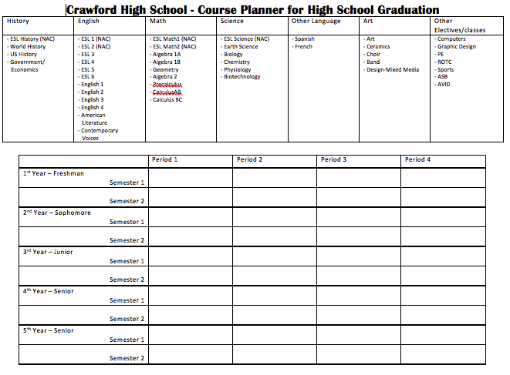
High School Course Planner:

Activity Four: Art Analysis
Language Objective:
- Students will respond to short answer questions about the goal or dream of the subject of the painting.

Learning Objective:
- Students will analyze the painting and the sculpture to infer what the goal or dream is of the subject of the painting.
- Students will paint a picture or create a sculpture of their own goal or dream.

Materials:
- Copies of “Art Analysis” worksheet with teacher selected painting and a sculpture included for analysis. *To make the activity more successful, choose painting and sculpture that show a subject with a clear goal that will invite rich observation and discussion from the students.
- Paint and paintbrushes.
- Paper/canvas for painting on.

Procedures:
- Show students the painting, ask students to describe what they see. After they mention the subject of the painting, ask them what they think he or she wants or what is his or her goal. Allow for a discussion based on all of the things in the painting and if they think the person’s goal may be related to one of those objects.

- Pass out the Art Analysis worksheet and direct the students to begin answering the questions that will help them analyze the painting. Facilitate discussion and critical thought by asking guiding questions about the goal of the subject as well as the goal of the painter.

- Have the students look at the picture of the sculpture on the back of the worksheet. Again, have them think about and then describe on their worksheets what they see. Then have them write about what they think the person is doing and what his or her ultimate goal may have been.

- Tell the students to begin thinking about their own goals and how they might use the artistic medium of paint or sculpting material to symbolize their own personal goal. Gather materials (paint, paintbrushes, clay, etc.) according to student preferences.

- On a future date, have the students choose whether they want to paint or sculpt and pass out the materials accordingly. Remind the students that they should be creating a piece that somehow represents their goals either through the subject of the painting or through the objects as representations of the artist’s own goals. As students work, ask guiding questions that help them to stay focused on creating a piece that represents their goals in some way so they don’t loose focus on the goal they are attempting to represent.
Art Analysis
Painting Analysis:

What do you see in the painting?
_____________________________________________________________________________________
What do you think the person is thinking about or feeling?
_____________________________________________________________________________________
Why do you think that?
_____________________________________________________________________________________
What do you think is their goal? What do they want?
_____________________________________________________________________________________
Why do you think that?
_____________________________________________________________________________________
Sculpture Analysis:

What do you see in the painting?
_____________________________________________________________________________________
What do you think the person is thinking about or feeling?
_____________________________________________________________________________________
Why do you think that?
_____________________________________________________________________________________
What do you think is their goal? What do they want?
_____________________________________________________________________________________
Why do you think that?
_____________________________________________________________________________________
Activity Five: Visual Storytelling
Language Objective:
- Students will read a fictional story and take notes on instances of figurative language, new vocabulary, and the overall theme of striving to reach one’s goals.

Learning Objective:
- Students will understand how figurative language can help with visualization of a story.
- Students will understand how to stay focused on a goal despite obstacles that may make it difficult to achieve.
- Students will learn to formulate a plan of action for achieving a goal.

Materials:
- Copy of “More Than Anything Else” by Marie Bradby (Bradby, 1995)
- Student copies of “More Than Anything Else” response worksheets
- *Computer with sound and document camera capabilities (if possible or desired)

Initial Procedures:
- Show students the cover of the book ask them what they see. Ask them what they think the boy on the cover is thinking about and what his goals in life might be. Refer back to the title.
- Explain to the students that they will be reading a book called “More Than Anything Else” and ask them to predict what the book will be about.
- Share the format of the worksheets and point out the way the pictures are taken from the actual book and how they are arranged to go with each page of text.
- *If interested, and if possible, play the story as read aloud by Malcom Jamal Warner using the YouTube clip: https://www.youtube.com/watch?v=ZlYOdg7lOew.
- Explain to the students that you are going to play it straight through one time to get a sense of the tone and mood of the story.
- After the first continuous reading, read through the story again, but more slowly and clarify or explain instances of confusion. Also, highlight examples of figurative language and remind students of visualization when reading.

- After reading for a second time with more time to stop and clarify along the way, have students answer the questions on the last page to generate thought and discussion about goals. Guide the discussion to determining Booker’s goal and focus on how he was able to accomplish it.

Activity Five: Visual Storytelling cont.

Final Project Procedures:

- **For the final activity, share with the students that they will be writing their own story about their biggest goal.
- Pass out the worksheet titled, “My Story” and have them fill out their answers to both the story of Booker, and to begin telling their own story.
10. As the final project continues, guide students to include illustrations that accurately portray their goals. Also, remind students to include the steps they will need to accomplish their goals.
- Finally, help students prepare to present their stories by giving multiple opportunities for oral practice.

More Than Anything Else
by Marie Bradby

Response Questions

1. What is the boy’s goal? What does he want?

_________________________________________________________________________________________

_________________________________________________________________________________________

2. How did he accomplish (do/get) it?

_________________________________________________________________________________________

_________________________________________________________________________________________

3. What is your biggest goal?

_________________________________________________________________________________________

_________________________________________________________________________________________

4. How will you accomplish it? Be specific and give the exact steps you will take to do/get it!

First, I will ____________________________________________________________________________

Next, I will ____________________________________________________________________________

Then, I will ____________________________________________________________________________

Finally, I will ____________________________________________________________________________

Rubrics:

Each of these rubrics was developed with the ambition of measuring a student’s progress in English proficiency and on the depth of critical thought based on the characteristics of each individual activity. The rubrics are specific to each activity and would likely be modified if the activity were changed in any way.

All Activities:
Rubric for Critical Thought (used on all receptive activity responses):
0 | No Answer
1 | Nonsense, unintelligible, incomplete, unrelated answer
2 | Answer without insight (copied)
3 | Answer with partial insight
4 | Answer with some insight and some personal application
5 | Answer with deep insight and personal application

Activity 1 – I Have a Dream, Too
Rubric for “I Have a Dream, too” speech– Expressive Activity
Pronunciation | 5  Student can be understood without difficulty | 4  Student can be mostly understood with some difficulty | 3  Student can be partly understood with great difficulty | 2-0  Students can not be understood at all
Voice | 5  Student can be clearly heard | 4  Student can be mostly heard | 3  Student can barely be heard | 2-0  Student can not be heard
Eye Contact | 5  Student looks up and out at audience frequently | 4  Student looks up at audience at least twice | 3  Student looks up at audience at least once | 2-0  Student does not look up at audience
Content of Speech | 5  Student includes at least two original and/or specific ideas about their own goals | 4  Student includes ideas about their own goals, but it is not clear that the ideas are original (they may be copied from another student or from the original speech) | 3  Student does not include ideas about their own goals | 2-0  Student did not finish or did not present speech

Activity 2 – Photo Gallery
Rubric for Photo Gallery Response– Expressive Activity
- Student took a photo
1 | 2 | 3 | 4
Student took a photo of something, but it is not clear what is the subject of the photo | Student took a photo with a clear subject, but didn’t include a clear explanation | Student took a photo with a clear subject, and included an explanation that helped to understand their goals | Student took a photo of something with a clear subject and included an explanation that led to a deep understanding of their unique goals

Rubric for Photo Gallery Response– Expressive Activity
- Student used internet to find a photo
1 | 2 | 3 | 4
Student found a photo, but is not clear what is the subject of the photo | Student found a photo with a clear subject, but didn’t include a clear explanation | Student found a photo with a clear subject, and included an explanation that helped to understand their goals | Student found a photo of something with a clear subject and included an explanation that led to a deep understanding of their unique goals

Activity 3 – A-G Pathway to Graduation
Rubric for A-G Pathway to Graduation – Expressive Activity
1 | 2 | 3 | 4
Student did not complete the before and after course planners | Student completed the before and after course planners but didn’t include different choices | Student completed the before and after course planners and did include different choices that somewhat reflected the requirements of A-G | Student completed the before and after course planners and did include different choices that clearly reflected the requirements of A-G

Activity 4 – Art Response
Rubric for Art Response – Expressive Activity
1 | 2 | 3 | 4
Student created something, but it doesn’t show a clear subject or goal | Student created something, but it only vaguely shows a subject or goal | Student created something, and it shows a pretty clear subject or goal | Student created something, and it definitely shows a clear and original subject or goal

Activity 5 – Visual Storytelling
Rubric for Visual Storytelling – Expressive Activity
Pronunciation | 5  Student can be understood without difficulty | 4  Student can be mostly understood with some difficulty | 3  Student can be partly understood with great difficulty | 2-0  Students can not be understood at all
Voice | 5  Student can be clearly heard | 4  Student can be mostly heard | 3  Student can barely be heard | 2-0  Student can not be heard
Eye Contact | 5  Student looks up and out at audience frequently | 4  Student looks up at audience at least twice | 3  Student looks up at audience at least once | 2-0  Student does not look up at audience
Content of Story | 5  Student wrote three paragraphs or more, and it definitely describes a clear and original subject or goal | 4  Student wrote three paragraphs, and it describes a pretty clear subject or goal | 3  Student wrote something, but it only vaguely describes a subject or goal | 2-0  Student wrote something, but it doesn’t describe a clear subject or goal or is not finished
Visualization | 5  Student included at least three clear pictures or visual representations of their goals and plans to achieve them | 4  Student included two visuals that represented their goals or plans, and/or they weren’t clear representations of that student’s goals | 3  Student included one visual that represented their goals or plans, and/or they weren’t clear representations of that student’s goals | 2-0  Student did not include any visuals that represented their goals or plans, and/or they weren’t clear representations of that student’s goals

References

Au, K. H. (1998). Social constructivism and the school literacy learning of students of diverse backgrounds. Journal of Literacy Research, 30(2), 297–319. doi:10.1080/10862969809548000
Auerbach, E. (1990). Making meaning, making change: A guide to participatory curriculum development for adult ESL and family literacy. Retrieved from http://eric.ed.gov/?id=ED321593
Biraimah, K. (2005). Achieving equitable outcomes or reinforcing societal inequalities? A critical analysis of UNESCO’ education for all and the United States’ No Child Left Behind programs. Educational Practice and Theory, 27(2), 25–34. doi:10.7459/ept/27.2.03

Blanton, L. L. (1992). A holistic approach to college ESL: Integrating language and content. ELT Journal, 46(3), 285–293. doi:10.1093/elt/46.3.285
Blau, S. D. (2003). The literature workshop: Teaching texts and their readers. Portsmouth, NH: Heinemann.
Bradby, M. (1995). More than anything else. New York: Orchard Books.

Bronfenbrenners Ecological Systems Theory. (n.d.). EDFD127 -. Retrieved July 6, 2014, from http://edfd127.wikispaces.com/Bronfenbrenners+Ecological+Systems+Theory
Bronfenbrenner, U. (1986). Ecology of the family as a context for human development: Research perspectives. Developmental Psychology, 22(6), 723–742. doi:10.1037/0012-1649.22.6.723
Carrier, K. A. (2003). Improving high school English language learners’ second language listening through strategy instruction. Bilingual Research Journal, 27(3), 383–408. doi:10.1080/15235882.2003.10162600
Chamot, A. U., & O’Malley, J. M. (1987). The cognitive academic language learning approach: A bridge to the mainstream. TESOL Quarterly, 21(2), 227–249. doi:10.2307/3586733
Chavez, G. (2013). Examining the reliability and validity of ADEPT and CELDT: Comparing two assessments of oral language proficiency for English language learners (Doctoral dissertation, Loyola Marymount University).

Clément, R., Dörnyei, Z., & Noels, K. A. (1994). Motivation, self-confidence, and group cohesion in the foreign language classroom. Language Learning, 44(3), 417–448. doi:10.1111/j.1467-1770.1994.tb01113.x
Collier, V. P. (1987). Age and rate of acquisition of second language for academic purposes. TESOL Quarterly, 21(4), 617–641. doi:10.2307/3586986
Crandall, J. (Jodi). (1992). Content-centered learning in the U.S. Annual Review of Applied Linguistics, 13, 110–126. doi:10.1017/S0267190500002427
Davis, J. E. (2014). Civil Rights Movement. Grolier Multimedia Encyclopedia. Retrieved July 1, 2014, (use the date you accessed the page) from Grolier Online http://gme.grolier.com/article?assetid=0063993-0
Decapua, A., & Marshall, H. W. (2010). Serving ELLs with limited or interrupted education: Intervention that works. TESOL Journal, 1(1), 49–70. doi:10.5054/tj.2010.214878
Dooley, K. (2009). Re-thinking pedagogy for middle school students with little, no or severely interrupted schooling. English Teaching: Practice & Critique, 8(1), 5-19.
Elbow, P. (2002). The cultures of literature and composition: What could each learn from the other? College English, 64(5), 533–546. doi:10.2307/3250752
Freire, P. (2000). Pedagogy of the oppressed: 30th Anniversary Edition. New York: Bloomsbury Academic Continuum.
Freire, P., & Macedo, D. (1987). Reading the word and the world. South Hadley, MA: Bergin & Garvey.

Gandara, P., Rumberger, R., Maxwell-Jolly, J., & Callahan, R. (2003). English learners in California schools: Unequal resources, unequal outcomes. Education policy analysis archives, 11(36), 1-54.
Garcia, O., Kleifgen, J. A., & Falchi, L. (2008). From English Language Learners to Emergent Bilinguals. Equity Matters. Research Review No. 1. Campaign for Educational Equity, Teachers College, Columbia University, New York.
Genesee, F. (1999). Program alternatives for linguistically diverse students. Retrieved from http://escholarship.org/uc/item/95t956xz#page-5
Genesee, F., Lindholm-Leary, K., Saunders, W., & Christian, D. (2005). English language learners in U.S. schools: An overview of research findings. Journal of Education for Students Placed at Risk (JESPAR), 10(4), 363–385. doi:10.1207/s15327671espr1004_2
Goh, C. (1997). Metacognitive awareness and second language listeners. ELT Journal, 51(4), 361–369. doi:10.1093/elt/51.4.361
Goldenberg, C. (2013). Unlocking the research on English learners: What we know--and don't yet know--about effective instruction. American Educator, 37(2), 4.

Hadaway, N. L., Vardell, S. M., & Young, T. A. (2001). Scaffolding oral language development through poetry for students learning English. The Reading Teacher, 54(8), 796–806.
Harper, C., & de Jong, E. (2004). Misconceptions about teaching English-language learners. Journal of Adolescent & Adult Literacy, 48(2), 152–162. doi:10.1598/JAAL.48.2.6
Hawkins, M. R. (2004). Researching English language and literacy development in schools. Educational Researcher, 33(3), 14–25. doi:10.3102/0013189X033003014
Heilig, J. V. (2011). Understanding the interaction between high-stakes graduation tests and English learners. Teachers College Record, 113(12), 2633-2669.

Hones, D. F. (2007). A meeting place for us: Milpera, a newcomer high school. Multicultural Education, 14(4), 8-15.
Hou, F., & Beiser, M. (2006). Learning the language of a new country: A ten-year study of English acquisition by south-east Asian refugees in Canada. International Migration, 44(1), 135–165. doi:10.1111/j.1468-2435.2006.00358.x
King, Jr., M. (1963, August 28). Martin Luther King's "I Have a Dream" speech. Retrieved August 11, 2014, from http://www.archives.gov/press/exhibits/dream-speech.pdf
Hung, D. W. L., & Chen, D.-T. (2001). Situated cognition, Vygotskian thought and learning from the communities of practice perspective: Implications for the design of web-based E-learning. Educational Media International, 38(1), 3–12. doi:10.1080/09523980121818
Iddings, A. C. D., Risko, V. J., & Rampulla, M. P. (2009). When you don’t speak their language: Guiding English-language learners through conversations about text. The Reading Teacher, 63(1), 52–61. doi:10.1598/RT.63.1.5
Jacob, B. A. (2001). Getting tough? The impact of high school graduation exams. Educational Evaluation and Policy Analysis, 23(2), 99–121. doi:10.3102/01623737023002099
Janzen, J. (2008). Teaching English language learners in the content areas. Review of Educational Research, 78(4), 1010–1038. doi:10.3102/0034654308325580
Kleyn, T., & Reyes, S. A. (2011). Nobody said it would be easy: ethnolinguistic group challenges to bilingual and multicultural education in New York City. International Journal of Bilingual Education and Bilingualism, 14(2), 207-224.

Klingner, J. K., & Edwards, P. A. (2006). Cultural considerations with response to intervention models. Reading Research Quarterly, 41(1), 108–117. doi:10.1598/RRQ.41.1.6
Krashen, S. (1982). Principles and practice in second language acquisition. Oxford: Pergamon.
Lantolf, J. P., & Pavlenko, A. (1995). Sociocultural theory and second language acquisition. Annual Review of Applied Linguistics, 15, 108–124. doi:10.1017/S0267190500002646
Luster, T., Qin, D., Bates, L., Rana, M., & Lee, J. A. (2010). Successful adaptation among Sudanese unaccompanied minors: Perspectives of youth and foster parents. Childhood, 17(2), 197-211.
McBrien, J. L. (2005). Educational needs and barriers for refugee students in the United States: A review of the literature. Review of Educational Research, 75(3), 329–364. doi:10.3102/00346543075003329
Meltzer, J., & Hamann, E. T. (2005). Meeting the literacy development needs of adolescent English language learners through content-area learning – Part two: Focus on classroom teaching and learning strategies. Faculty Publications: Department of Teaching, Learning and Teacher Education. Retrieved from http://digitalcommons.unl.edu/teachlearnfacpub/53

Miller, J. (2009). Teaching refugee learners with interrupted education in science: Vocabulary, literacy and pedagogy. International Journal of Science Education, 31(4), 571–592. doi:10.1080/09500690701744611
Park, J. Y. (2012). A different kind of reading instruction: Using visualizing to bridge reading comprehension and critical literacy. Journal of Adolescent & Adult Literacy, 55(7), 629–640. doi:10.1002/JAAL.00074
Popkewitz, T. (2013). Critical Theories in Education: Changing Terrains of Knowledge and Politics. Routledge.

Richman, C. L., Brown, K. P., & Clark, M. (1987). Personality changes as a function of minimum competency test success or failure. Contemporary Educational Psychology, 12(1), 7–16. doi:10.1016/S0361-476X(87)80034-6
Rumberger, R. W., & Gandara, P. (2004). Seeking equity in the education of California’s English learners. Teachers College Record, 106(10), 2032-2056
Shanahan, T. (2008). The national literacy panel for language minority children and youth. Retrieved August 10, 2014, from http://www2.ed.gov/programs/readingfirst/2008conferences/teaching2.pdf
Short, D. J., & Boyson, B. A. (2000). Newcomer programs for linguistically diverse students. NASSP Bulletin, 84(619), 34–42. doi:10.1177/019263650008461904
Street, B. (1997). The implications of the “New Literacy Studies” for literacy education. English in Education, 31(3), 45–59. doi:10.1111/j.1754-8845.1997.tb00133.x
Street, B. V. (2005). At last: Recent applications of new literacy studies in educational contexts. Research in the Teaching of English, 39(4), 417–423. doi:10.2307/40171646
Walqui, A. (2006). Scaffolding instruction for English language learners: A conceptual framework. International Journal of Bilingual Education and Bilingualism, 9(2), 159–180. doi:10.1080/13670050608668639
Waters, M. C., & Jiménez, T. R. (2005). Assessing immigrant assimilation: New empirical and theoretical challenges. Annual Review of Sociology, 31, 105–125.
Weisner, T., (2002). Ecocultural understanding of children’s developmental pathways. Human Development, 45, 275-281.
Wells, B. D. ., Gambero, L., Allen, M., & Juarez, A. (2012). Raising THE bar. Principal Leadership, 12(6), 36–39.
Wu, X. (2003). Intrinsic motivation and young language learners: The impact of the classroom environment. System, 31(4), 501–517. doi:10.1016/j.system.2003.04.001

